X-Field Description and Dataset

1.1 Introduction

This field development programme describes the proposed development of the X-field by Xenon, a public limited company. The X-field is located approximately 210km East North East of mainland Britain in the Central North Sea in block UKCS 22/12.
There are numerous neighbouring fields located close to the X-field, as can be seen in figure 1. Nearby existing developments include Nelson, 10km to North North West, and Forties, 40km North West. Other existing facilities include the Forties pipeline system, the Fulmar gas pipeline and the central area transmission system. The X-field lies in 81m of water.

1.2 History

Six appraisal wells penetrated the oil bearing Jurassic reservoir from 10126ft to 11175ft two years ago (see figure 2). Wells X-1 and X-2 are vertical and wells X-3 to X-6 are deviated by up to 25 degrees. All six were subsequently abandoned. From this appraisal phase various sources of information were collected. Mud logs were recorded during the drilling of each well. Four wells tests were carried out and 8 uncontaminated fluid samples collected. Each well was petrophysically logged. A 2-dimensional seismic cross section of the reservoir was also taken.

1.3 Seismic Information

The available seismic is 2D and was shot in an NNW to SSE direction (see figure 3 and 4). The seismic is of moderate quality.

1.4 Petrophysical Data

1.4.1 Wireline Logs
Petrophysical logs which were run on all of the wells in the X-field. A full list of the logs that were run can be found in Table 1. The mud type in all the wells (with the exception of well 6 which is OBM) is a potassium system WBM.

    - Core
Core porosity, permeability and capillary pressure measurements are available for wells X1, X4 and X5.
Examination of core samples indicated that the reservoir sand is relatively well consolidated. A small interval was identified as being slightly more friable. Sonic travel time also indicated that the reservoir sand is friable to moderately hard.

1.5 Reservoir Fluids
PVT Analysis
Fluid samples from a total of eight depth intervals in exploration wells X-1 and X-2 were considered uncontaminated (or present in sufficient quantity) and therefore suitable for analysis. Two down hole samples from well X-1 were collected, but only one, at 10362 ft (TVDSS) was analysed because the oil content of the other sample was found to be far from sufficient to complete an analysis. Eight valid samples were collected both from the wellhead and separator during the drill stem testing of wells X-2, X-3, X-5 and X-6. A second PVT analysis was performed on surface samples collected from well X-3 and the results were compared with those obtained from the down hole samples. The results of these PVT analyses are presented in table 2.

Changing the separator pressures and temperature results in a different formation volume factor being obtained in both PVT reports from wells X-1 and X-2 (see appendix D, figures D.1, D.2, D.3, D.4). A normalisation process was performed in order to obtain an acceptable average oil formation volume factor for both wells and to use across the entire reservoir (see appendix D) [4].

The average formation volume factors obtained from both wells X-1 and X-2 are similar and are presented in figures 2 and table 3. The average reservoir fluid composition is shown below in table 4. From production technology optimisation it is known that a two stage separation process will be required in the field. First stage separation pressure is to be 300 psi, 200ºF and the second stage with pressure at 30 psi, 80ºF.

From the Drill stem test performed in the 100% water bearing sand, a formation water sample was obtained and submitted to the laboratory for testing. The results are presented in tables 5 and 6.

1.6 Reservoir Pressure

Repeat Formation Tester
RFT tests have been conducted for three well; X1, X2, and X5 to find the original reservoir pressure and oil water contacts.

The measured pressure (Psi) at different depths (TVSS in feet) and the observed oil water contacts are summarised in table 7.

1.7 Well performance

Drill stem testing
Drill Stem Tests were carried out on wells X-2, X-3, X-5 and X-6. No tests were conducted on wells X-1 and X-4.

A software package, entitled Pansystem, was used to analyse the well test responses. Input parameter data, including formation volume factor, total system compressibility for example were calculated from the PVT analyses (see section 2.4) and parameters such as porosity, water saturation, layer thickness and so on were obtained from the petrophysical analysis (see section 2.3).

An injectivity test was also carried out in the aquifer. However, the results indicate that permeability is low and that the aquifer sand is very tight. The injectivity index is so low that injection in the aquifer, to provide pressure support, will not be possible. Therefore it has been decided that injection into the transition zone at the base of the oil leg is the best option for maintaining reservoir pressure.

Tables 2.6.1-2.6.5 show the results of the well test analyses carried out in the field. Wellbore Storage (Cs) was obtained from the diagnostic (log-log plot), permeability and skin from semilog plot and P* from the liner flow plot. The selected data will be used for the finalisation of the development plan and to help in understanding the differing productivity and reservoir properties of various areas of the reservoir.

1.7.1 Well 2 (Productivity test)

The bottom hole pressure survey results of well 2 are shown in Tables 2.6.1 and 2.6.2. The Plots can be found in appendix F.

Figures F.1-F.8 of appendix are the results of the analysis of the last build-up, owing to their longer duration. More accurate results are obtained by analysing the build-up rather than the drawdown because maintaining a constant rate during drawdown is not always possible. The productivity test overview in appendix F, figure F.1 shows that the duration of test is not long enough to reach semisteady state, although it does approach this towards the end of the test. Thus the exact determination of the position of the late time region boundary is not possible.

Figure F.2 (appendix F) shows the type curve matching. Because the test is too short it is not possible to fully determine what the boundary type is, it matches with U-shaped, parallel and intersecting fault models. This well is in one of the corners of the field and in this case is interpreted as being between parallel faults.

A permeability thickness of about 35000mDft was calculated on the basis of fluid parameters and the extrapolated pressure is approximately 5710 psi. However, this pressure is not very reliable because the build-up test is too short and because the fall-off period after the injectivity test shows a discontinuity in the reservoir. The quick match results justify these results.

Table 2.6.1:Well 2- Production test

Parameter | Diagnostic  (log-log plot) | Semilog plot(Radial flow)  (Specialised plot) | Linear flow plot  (Specialised plot) | Quickmatch
Cs | 0.2012 | - | - | 0.032
k | 247 | 247 | 303 | 273
kh | 34640 | 34647 | - | -
S | 1.65 | 1.67 | 3.35 | 2.5
W | 635 | - | 462 | 488
L1 | - | - | 158 | 190
L3 | - | - | 304 | 298
P* | - | 5678 | 5710 | 5710
Rinv |  | 1214
FE |  | .8295

2.6.2 Well 2 (Injectivity Test):

Figures 9-15 (appendix F) show the results of the injectivity test in the aquifer. Figure F.9 (appendix F, test overview) shows that injectivity in the aquifer is very low and to inject at a rate of 3600 bbl/day, a surface pressure of 8000psi is necessary. In figure F.10 the fall-off period is analysed as a build-up and the X-axis in diagnostic plot is elapsed time.

The permeability is very low (14mD) in aquifer because where as digenesis stopped in the reservoir after oil emplacement, it continued in the reservoir. The skin is very high because the sand is very thick (675 ft) but the well is only completed over a small part of it (perforated thickness is just 20 feet) and so most of this skin is a geometrical skin associated with limited entry.

The late time region in the diagnostic plot has a unit slope [5] and the boundary model selected is that of 2-cell compartmentalised. In this boundary model there are two cells with a 'leaky' connection between them and when water is injected in one cell it flows to other cell. Because of the presence of a barrier (although discontinuous) and the low water zone permeability, it is very difficult to inject in the aquifer. The quick match results support this statement.

Table 2.6.2:Well 2- Injectivity test in water zone

Parameter | Diagnostic  (log-log plot) | Semilog plot(Radial flow)  (Specialised plot) | Linear flow plot  (Specialised plot) | Quick match
Cs | 0.0183 | - | - | 0.009
k | 14.25 | 14.13 | - | 15.7
kh | 9619 | 9541 | - | -
S | 112.6 | 111.7 | - | 65
W | - | - | - | 488
L1 | - | - | - | 97
L2 | - | - | - | 27
L3 | - | - | - | 78
L4 | - | - | - | 2
Teff | - | - | - | 0.3
V2 |  |  | - | 112020
P* | - | 5840 | 5840 | 5226
Rinv |  | 400 ft | - | -
FE |  | 0.053 | - | -

1.7.3 Well 3 (Productivity test)

Figures 16-21 (appendix F) display the plots of this well test analysis. Table 2.6.3 displays the permeability and skin factor. In figure 16 the test overview is shown.

Figure 18 is the diagnostic plot of the last build-up, it illustrates in late time region that the derivative first increases and then decreases, and this is a complex situation, which indicates the presence of aquifer support.

In figure 17 the type curve matching of the gas cap/aquifer support model only matches the end of derivative curve. This is because the well is located in a situation like that illustrated in the below schematic (figure 2.6.1). In this reservoir layer the permeability is constant but the thickness varies across the field. At the beginning of the test, the effect of the thicker region does not reach the well and the derivative plot shows one boundary. As the build-up proceeds the effects of the thicker region become apparent and the derivative shows a constant pressure boundary related to weak aquifer support. The diagnostic plot (figure F.18) shows that the pressure towards the end of the build-up section is almost constant and this justifies the use of the constant pressure boundary model [1].

Figure 2.6.1: Schematic well 3 location in the reservoir

Well 3
Reservoir Thickness

Reservoir Thickness

Another justification for this model is illustrated in appendix F, figure F.21 (the drawdown diagnostic plot). This is because in this plot, the pressure derivative curve also decreases in late time region, however the data is very noisy. If the pressure derivative curve in both the build-up and drawdown period decrease in the late time region then the model selected is the constant pressure boundary model.

Table 2.6.3:Well 3- Production test
Parameter | Diagnostic  (log-log plot) | Semilog plot(Radial flow)  (Specialised plot)
Cs | - | -
K_{P} | 2278 | 2163
S | - | -0.621
r_{i} | - | 928 ft

1.7.4 Well 5 (Productivity test)

Results of the analysis are displayed in table 2.6.5 and the plots are can be found in appendix F, figures F.22-29. This test is also of a short duration and in figure 23, exact boundary detection is not possible - it may indicate parallel faults, intersecting faults or u-shaped fault models. Geological data supports the possible existence of a u-shaped fault.

The results in table 2.6.4 give a permeability of around 800mD and a skin about 22. The extrapolated pressure is 4325 psi. The reason that the extrapolated pressures of the different wells are not the same is that tests were not conducted at the same time. (This test was carried out about one year after the tests were conducted on wells 2 and 3 and during this period the wells have produced about 7.7MMbbl. Because of weak aquifer support the pressure has decreased).

Figure F.27 (appendix F) shows that the drawdown data does not exactly match with the quick match curve at the beginning of the test. The reason for this is that the skin is changing and decreasing due to well clean up and during this period the pressure increases slightly.

To match the beginning exactly the skin must be increased but doing this means that it is not possible to match the build-up section. The software used does not take into account the clean up effect.

Table 2.6.4:Well 5- Production test

Parameter | Diagnostic  (log-log plot) | Semilog plot(Radial flow)  ( Specialised plot) | Linear flow plot  (Specialised plot) | Quick match
Cs | 0.2461 | - | - | 0.02
k | 657 | 719 | 2070 | 810
kh | 193786 | 212261
S | 19.36 | 21.81 | - | 22
W | - | - | 983 | -
L1 | - | - | - | 910
L2 |  |  |  | 10
L3 | - | - | - | 595
P* | - | 4301 | 4323 | 4325
Rinv | - | 2270 | -
FE | - | .2844 | -

1.7.5 Well 6 (Productivity test)

Figures F.30-36 (appendix F) show the plots obtained and table 2.6.5 the results. In figure F.31 the type curve matching almost exactly matches with the constant pressure boundary model. Permeability and skin from the semilog plot are about 1000mD and 8.4 respectively.

The quick match results show a good match with the data in figure F.35 (appendix F). The limited entry effect also exists but is not as strong. The extrapolated pressure is approximately 4818 psi, this pressure is different from other wells because of the time period between tests [6&7].

Table 2.6.5:Well 6- Production test

Parameter | Diagnostic  (log-log plot) | Semilog plot(Radial flow)  ( Specialised plot) | Linear flow plot  (Specialised plot) | Quick match
Cs | 0.2945 | - | - | 0.015
K_{p} | 2885 | 996 | - | K=730
Kh_{p} | 144269 | 49918
S | - | 8.42 | - | 4.7
Kz | - | - | - | 1.605
h_{top} | - | - | - | 3 ft
h_{p} | - | - | - | 50 ft
P_{i} | - | - | - | 4818

1.7.7 Well Testing Conclusion

Results for some wells demonstrate that the reservoir has a degree of support from the aquifer, although it is very weak. This is illustrated by the fact that after one years production the reservoir pressure has decreased by about 1000 psi. The results highlight the fact that there are many faults in the reservoir, but the determination of the exact position and orientation is not possible because the data is very noisy and the quality of the tests poor. These factors are the cause of uncertainty in the results obtained.

The oil zone permeability varies between layers from 200 mD - 1D. In the perforations permeability it is about 2-3mD. Production rates during the tests were high, as illustrated in the table above and productivity index is therefore correspondingly high. The results can be seen in table 2.6.6.

Table 2.6.6:Productivity Index of different wells

 | Bo | Uo | S | K | kh | m | Q | Pwf | P* | PI Actual | Pskin | PI Ideal
WELL 6: | 1.34 | 0.44 | 8.42 | 998 | 49918 | 41.7 | 19530 | 4230 | 4818 | 33 | 305 | 69.13
WELL 5: | 1.35 | 0.44 | 21.81 | 719 | 212262 | 8.43 | 15600 | 4078 | 4322 | 64 | 160 | 185.65
WELL 3: | 1.345 | 0.47 | -0.6 | 2163 | 54096 | 49.32 | 25000 | 4759 | 5193 | 58 | -26 | 54.38
WELL 2: | 1.35 | 0.47 | 1.6 | 247 | 34647 | 11.52 | 3781 | 5580 | 5710 | 29 | 16 | 33.18

The results of the injectivity test in the water zone indicate that permeability is low and that the aquifer sand is very tight. The injectivity index in the aquifer is low and so injection into the aquifer in order to provide pressure support will not be possible. Therefore it has been decided that injection into the transition zone at the base of the oil leg is the best option for maintaining reservoir pressure.

1.7.8 Sand Control

1.7.8.1 Sand failure prediction

From the six drill stem tests performed in 4 wells only one of them showed sand production of 4lbs/1000 bbl at production rates around 4500 bbl/day. Tests performed in the other wells were carried out at much higher flow rates 20,000-25,000 bbl/day and did not show any sand production. The allowed sand production limit at flow rates of below 5000 bbl/day is 30lbs/1000 bbl of fluid. Due to the lack of sand production problems in any other well it is possible that the sand produced during this test may be due to well clean up in the beginning of production.

Examination of the core in the laboratory showed that it was relatively well consolidated. A small interval was identified as being slightly more friable.

The mud log data for the six wells allow us to identify three distinct sand layers based on completion/mud log characteristics. The upper sand is of a fine grain size, spherical and is friable to moderately hard. The middle sand is fine to medium grained and is also friable to moderate hard. The lower sand is fine to medium grained and is moderately hard to friable.

1.7.8.2 Scaling

The analysis of the formation water obtained from well X-2, showed that although there is a high level of total dissolved solids (72 mg/l), the concentration of barium sulphate is low. A compatibility test performed using filtered seawater and formation water identified a small amount (concentration 2ppm) of scale formation. A scale inhibitor treatment will be carried out to avoid scale accumulation.

1.7.8.3 Wax, Asphaltenes

The asphaltene content of the oil is estimated at 0.4 %wt from tests in well X-2. This is relatively low. No asphaltene deposition was observed during drill stem testing but no detailed analysis into asphaltene deposition has been carried out.

The wax content in well 2 is estimated to be about 6.1wt%, which is relatively high.

1.7.8.4 Corrosion

Analysis of the production test performed in well X-2 showed the existence of Hydrogen Sulphide and Carbon Dioxide at concentrations of about 10ppm and 1.5% respectively.

3 Economics and commercial considerations

3.1 Introduction

The X-field, as previously described, is located in the Central North Sea, in block is 22/13a-1 and in a water depth of 81m. The X-field is situated in an active area of the North Sea and is surrounded by existing field developments. The Nelson asset, operated by Enterprise Oil, is located 15 km North West, Montrose is 10 km South and Z, Y and V fields are to be found 12 km North, 15 km Northeast and 10 km East respectively. The Forties field, operated by BP and acting as the collection point for the FPS, is sited 30 km Northwest.

Numerous options are available in order to economically optimise the development choice. A final development option must be made based on integration of the engineering, economic and technical aspects of possible developments.

3.2 Assumptions In The Net Cash Flow
The assumptions that used in the economical net cash flow analysis are as follows:

- Inflation: Considered to be at a rate of 3 %, which is representative of a reasonable period of years in the UK.

- Oil price: Assumed value is 15 $/bbl in real terms, constant during the life of the project. Although oil price was constant at approximately 23 $/bbl last year, recent fluctuation in the volatile crude oil market means that the project should be viable at depressed prices.

- Exchange rate: Considered at 1.5 $/£ for the 18 year life of project [5].

- Gas price: Considered constant at 2.5 [6] $/MScf in real terms for duration of project.

- Gas and oil tariff: These prices have been negotiated with a representative of BP. Oil and gas tariffs will be charged at 0.6 £/bbl and 0.5 £/MScf of oil and gas respectively. They are considered in real terms and will be constant for the life of the project.

- Corporation tax: A consolidated tax scheme is assumed, supposing that the company is engaged in different projects at the same time. Corporation tax is assumed to be charged at 30 % for the life of the project. Abandonment will be claimed at 100 % in the year of expenditure.

- Payments: Transactions carried out half in year considered and half the following year.

- Discount factor: Perhaps the variable with the greatest impact on economic analysis, Xenon considers a discount rate of 10 % representative, based on other North Sea economic valuations and is a DTI assumption.

- Questor analysis: As indicated earlier, the project valuation software uses a database of historical data [4].

APPENDIX A

WELL AND FIELD DATA
FIGURES AND TABLES

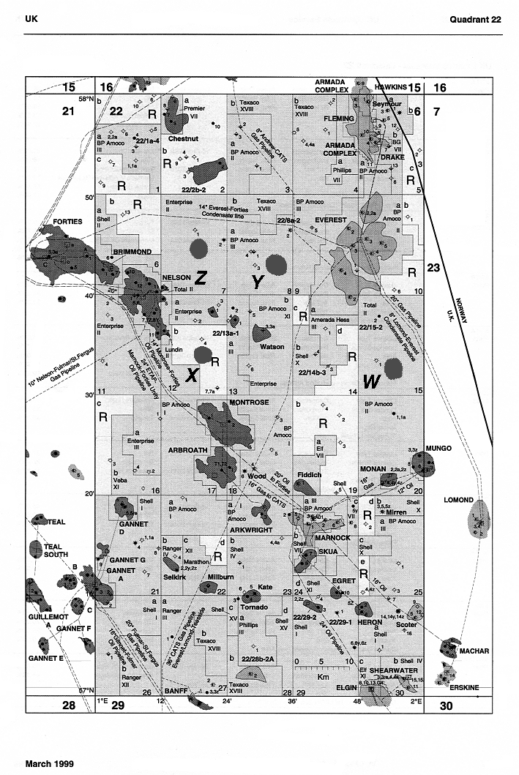
V

Figure 1: X-field location

9900
1
2 Kms
N
10100
10300
10500
10700
10900
11100
1
2
6
3
4
5
9800
Exploration well top reservoir location
Depth to top reservoir (Feet subsea)

Figure 2 Top structure Map with appraisal well location

9900
1
2 Kms
N
10100
10300
10500
10700
10900
11100
1
2
6
3
4
5
9800
Exploration well top reservoir location
Depth to top reservoir (Feet subsea)
Seismic Line and cross section 2 (see appendix B)

Figure 3 Top structure map with seismic line and cross sections (found in appendix B)

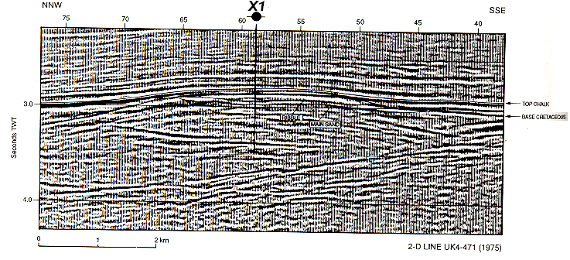

Figure 4: Seismic Section

Well | Log | Run | Depth (MD)
 |  |  | From | To
X1 | ISF/Sonic | 1 | 1326 | 5513
 |  | 2 | 5484 | 9850
 |  | 3 | 9808 | 11813
 |  | 4 | 11600 | 12920
 | FDC/CNL | 1 | 5482 | 9851
 |  | 2 | 9808 | 11813
 |  | 3 | 11600 | 12323
 | MICROLOG | 1 | 9811 | 11812
 | DLL | 1 | 9809 | 11813
 | DLL | 2 | 10200 | 12914
X2 | GR | 2 | 6840 | 12083
 | ISF/Sonic | 1 | 1987 | 6507
 |  | 2 | 6466 | 12077
 | FDC/CNL | 1 | 1987 | 6507
 |  | 2 | 6466 | 11095
 |  | 3 | 10700 | 12083
 |  | 4,5 | 10000 | 11261
 | MLL | 1 | 6466 | 12083
 | DLL | 1 | 6466 | 11095
X3 | ISF/Sonic | 1 | 6966 | NR
 | FDC/CNL | 1 | 6966 | 12388
 | DLL | 1 | 11086 | 12130
 | ISF/Sonic | 1 | 5909 | 10608
 |  | 2 | 10560 | 12924
X4 | FDC/CNL | 1 | 5909 | 10595
 |  | 2,3 | 10560 | 12930
 | MLL | 1 | 11350 | 12930
 | DLL | 1 | 10825 | 12930
X5 | ISF/Sonic |  | 6500 | 11846
 | FDC/CNL | 1 | 6703 | 11839
 |  | 2 | 10400 | 11711
 | MLL | 1 | 10500 | 11127
 | DLL | 1 | 10500 | 11132
X6 | ISF/Sonic | 1 | 9678 | 10449
 |  | 2 | 9684 | 11602
 | FDC/CNL | 2 | 9666 | 10445
 |  | 3 | 10430 | 11602

Table 1: X-Field Wireline Logs.

PVT Parameters | Initial conditions | Bubble point
Pressure (psia) | 5722 @ 10500 ft | 1800
Temperature (° F) | 250 | 250
Bo (^{R B}/_{STB}) | 1.323 | 1.395
Rs (^{SCF}/_{STB}) | 505 | 505
Viscosity (cP) | 0.49 | 0.41
Compressibility Co (10⁻⁶ Psi ⁻¹) | 10.4 | 18.0

Table 2 PVT Analysis

Test No.: Production test No. 2
Interval (ft TVDSS): 10,637-10672 and 10,688-10700

Analysis done by: Aberdeen
Date sampled: 23/6 (surface sample)

Specific gravity at 60/60ºF : 0.8306
API gravity at 60ºF : 39º
Water content : 0.15%
BS and W content : 0.15%v
Salt content : 0.0008%w NaCl
Kinematic viscosity at 100ºF : 3.04 cS
Pour points, ASTM maximum : -3 ºC
ASTM minimum : -36 ºC
Cloud point : 19.6 ºC
Paraffin wax content : 6.1 %w
Congealing point of wax : -
Sulphur content : 0.26%w
Asphaltene content : 0.40%w

Table 3 Average reservoir fluid proprieties

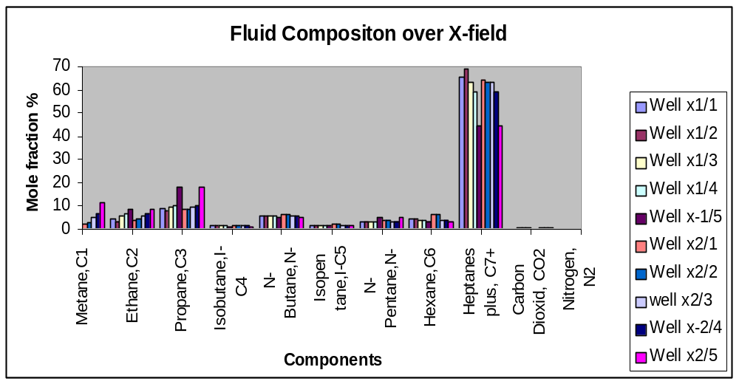

Figure 5 Oil Fluid Composition

Component | Mol%
Mathane, C₁ | 24.38
Ethane, C₂ | 9.41
Propane, C₃ | 9.37
Isobutane, C₄ | 1.29
N-butane, C₄ | 4.65
Isopentane, C₅ | 1.47
N-Pentane, C₅ | 2.61
Hexane, C₆ | 3.47
Heptane, C₇ | 41.66
Carbon dioxide, CO₂ | 0.54
Nitrogen, N₂ | 1.18
C₇ average Molecular weight | 218.17

Table 4 Average Reservoir fluid compositions

Test No.: Production test No. 1
Interval (ft TVDSS): 10,962-10982

Analysis done by: Aberdeen
Date sampled: 23.00 hrs on 16/6 (surface sample)

Cation/anion Concentration, mgm/litre

Na⁺ 47,833
K⁺ 2,344
Ca²⁺ 7,455
Mg²⁺ 674
Fe²⁺ (total) 43
Fe²⁺ (dissolved) 24
Ba²⁺ 9.5
Cl⁻ 90,912
SO₄²⁻ 295
HCO₃⁻ 220

pH = 5.85

Measured resistivity at 21.3ºC = 0.067 ohm-m
Measured resistivity at 93.3ºC = 0.023 ohm-m
Amount of suspended solids = 72 mgm/litre

Table: 5 Formation Water Proprieties Report

Test No.: Production test No. 1
Interval (ft TVDSS): 10,962-10982

- H₂S content:
Analysis done by: Aberdeen
Data analysed: 12/7
Data sampled: 16/6 (surface samples, taken upstream of the chokes)
Of four samples analysed, the average H₂S content in the produced water was 0.9 ppm

- Liberated gas analysis from bottom hole water sample:
Analysis done by: Flopetrol, Paris
Data analysed: 19/7
Data sampled: 07.08hrs 16/6 (subsurface samples)
Specific gravity of the water: 1.013 at 60ºF

Component Mol. %

N₂ 5.56
CO₂ 1.66
C₁ 81.73
C₂ 7.14
C₃ 2.44
iC₄ 0.24
nC₄ 0.65
iC₅ 0.16
nC₅ 0.18
C₆ 0.11
C₇ 0.10
C₈ 0.03

Molecular weight: 19.615
Specific gravity of the gases: 0.677 (Air = 1.0)
H₂S content < 0.1 ppm

Note: The dissolved gases were separated at 90ºC and atmospheric pressure. The recorded gas-liquid ratio = 14 scf/bbl

Table 6 Liberated Gas Analyses from Bottom Hole Water Sample Report

X-5 |  | X-2 |  | X-1
TVDSS  ft | Pressure  Psi | TVDSS  ft | Pressure  Psi | TVDSS  ft | Pressure  Psi
10,500 | 5,550 | 10,280 | 5,640 | 10,450 | 5,650
10,100 | 5,570 | 10,550 | 5,705 | 10,600 | 5,720
10,200 | 5,600 | 10,780 | 5,780 | 10,700 | 5,775
10,400 | 5,650 | 10,828 | 5,790 | 10,800 | 5,820
10,500 | 5,685 |  |  | 10,828 | 5,845
10,565 | 5,710
10,565 | 5,710 | 10,828 | 5,790 | 10,828 | 5,790
10,700 | 5,720 | 11,900 | 5,920 | 11,075 | 5,900
10800 | 5,820
11,100 | 5,920

Table 7 RFT Data

APPENDIX B

BACKGROUND WELL AND FIELD DATA

FIGURES AND TABLES

Table B.2: Important parameters and constants for different wells in the X field.

Parameter | Unit | Value
 |  | X-1 | X-2 | X-3 | X-4 | X-5 | X-6
MINIMUM DEPTH | ft | 10000 | 10000 | 10000 | 10570 | 10000 | 10350
MAXIMUM DEPTH | ft | 12950 | 12080 | 12130 | 12924 | 11856 | 11622
RMC | Ωm | 0.189 | 0.226 | 0.395 | 0.921 | 0.723
TRMC | F | 65 | 74 | 57 | 40 | 59 | 70
RM | Ωm | 0.123 | 0.103 | 0.214 | 0.248 | 0.195
TRM | F | 70 | 78 | 57 | 60 | 70 | 70
RMF | Ωm | 0.087 | 0.084 | 0.203 | 0.215 | 0.164
TRM | F | 65 | 74 | 57 | 40 | 59 | 70
RW | Ωm | 0.066 | 0.066 | 0.066 | 0.066 | 0.066 | 0.066
TRW | F | 60 | 60 | 60 | 60 | 60 | 60
BHT | F | 257 | 224 | 208 | 240 | 200
MEAN SURF TEMP | F | 60 | 60 | 60 | 60 | 60
ARCHIE A |  | 0.81 | 0.81 | 0.81 | 0.81 | 1.04 | 0.81
ARCHIE M |  | 2 | 2 | 2 | 2 | 1.81 | 2
SAT EXP (N) |  | 2 | 2 | 2 | 1.5 | 1.85 | 2
R SHALE | Ωm | 4 | 2.5 | 2.5 | 1.5 | 1.81
BIT SIZE | in | 8.5 | 12.25 | 8.5 | 8.5 | 2.5 | 8.5
MUD WEIGHT | lb/g | 11 | 11 | 10.96 | 12.11 | 12.5 | 11.9
FM SALINITY | ppm | 120000 | 120000 | 120000 | 120000 | 120000 | 120000
BH SALINITY | ppm | 40000 | 60000 | 40000 | 30000 | 35000 | 23000
O.D. CASING | in | 9.625 | 13.39 | 9.625 | 13.38 | 9.625 | 9.625
GR MATRIX | API | 82 | 70 | 70 | 60 | 55 | 55
RHO MATRIX | g/cc | 2.65 | 2.65 | 2.65 | 2.65 | 2.65 | 2.65
DT MATRIX | μs/ft | 86 | 86 | 86 | 86 | 86 | 86
CNL MATRIX | % | 0 | 27 | 0 | 20 | 0 | 0
GR SHALE | API | 105 | 87 | 85 | 105 | 70 | 70
RHO SHALE | g/cc | 2.52 | 2.2 | 2.25 | 2.25 | 2.45 | 2.38
DT SHALE | μs/ft | 77 | 75 | 75 | 85 | 85 | 85
CNL SHALE | % | 31.5 | 22 | 22.59 | 27 | 27 | 25.5
GR FLUID | API | 20 | 20 | 20 | 20 | 20 | 20
RHO FLUID | g/cc | 1 | 1 | 1 | 1 | 1 | 1
DT FLUID | μs/ft | 189 | 189 | 189 | 189 | 189 | 189
CNL FLUID | % | 100 | 100 | 100 | 100 | 100 | 100
DT MATRIX | μs/ft | 82 | 82 | 82 | 82 | 82 | 82

F-Well performance
Well 2:

Figure F.1
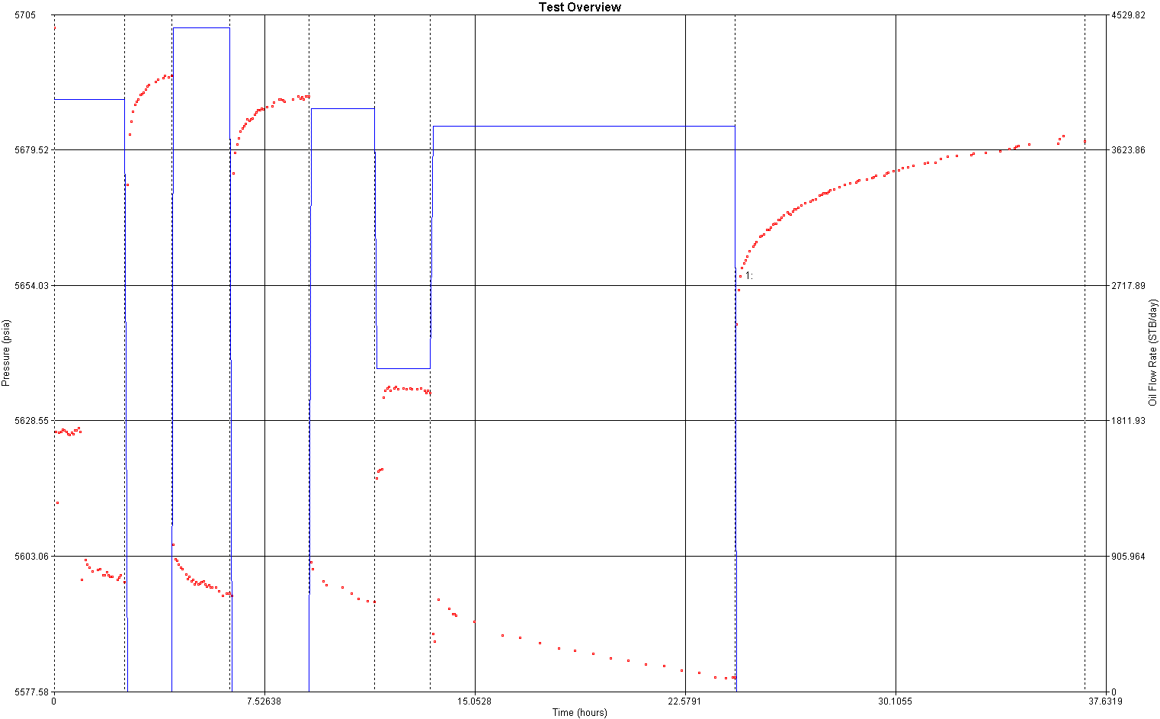

Figure F.2
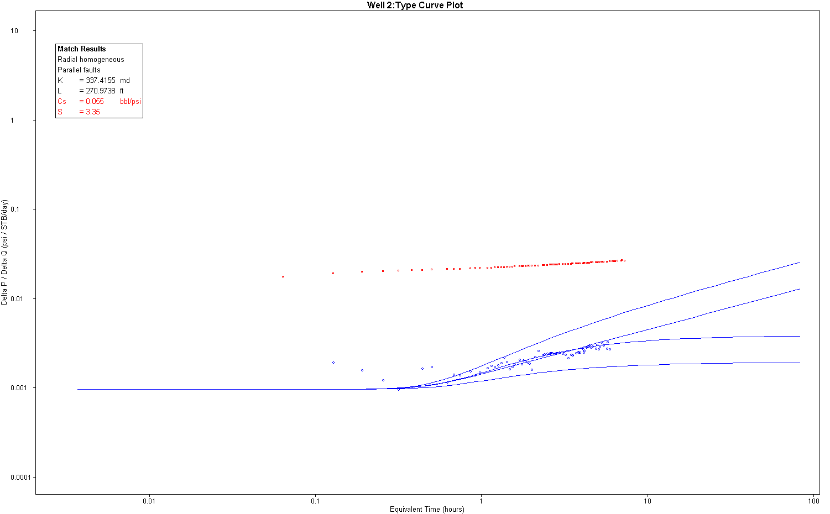

Figure F.3
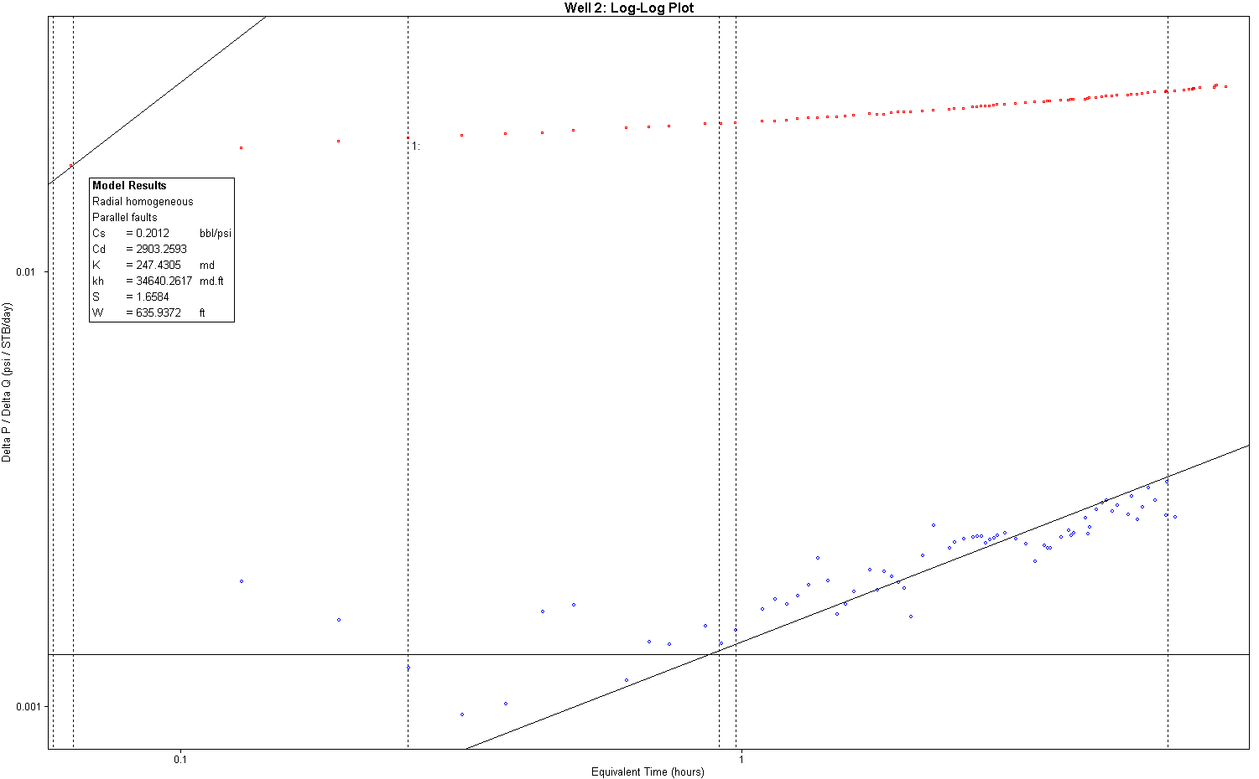

Figure F.4

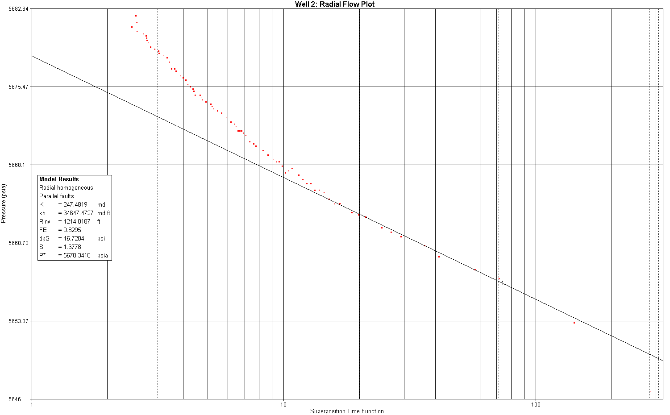

Figure F.5
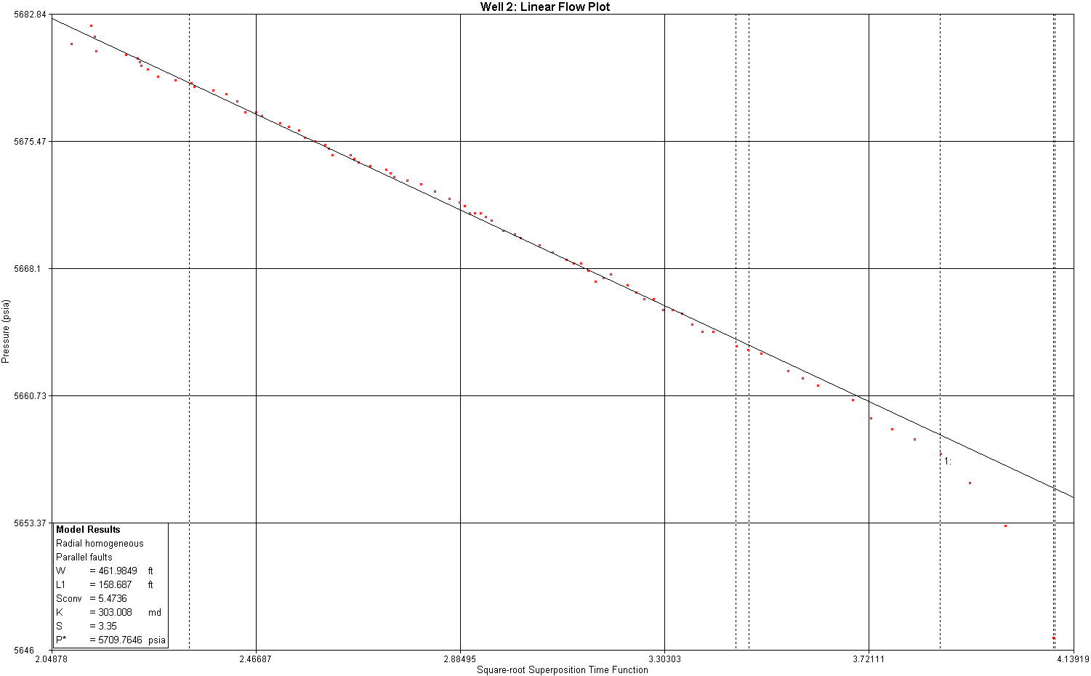

Figure F.6

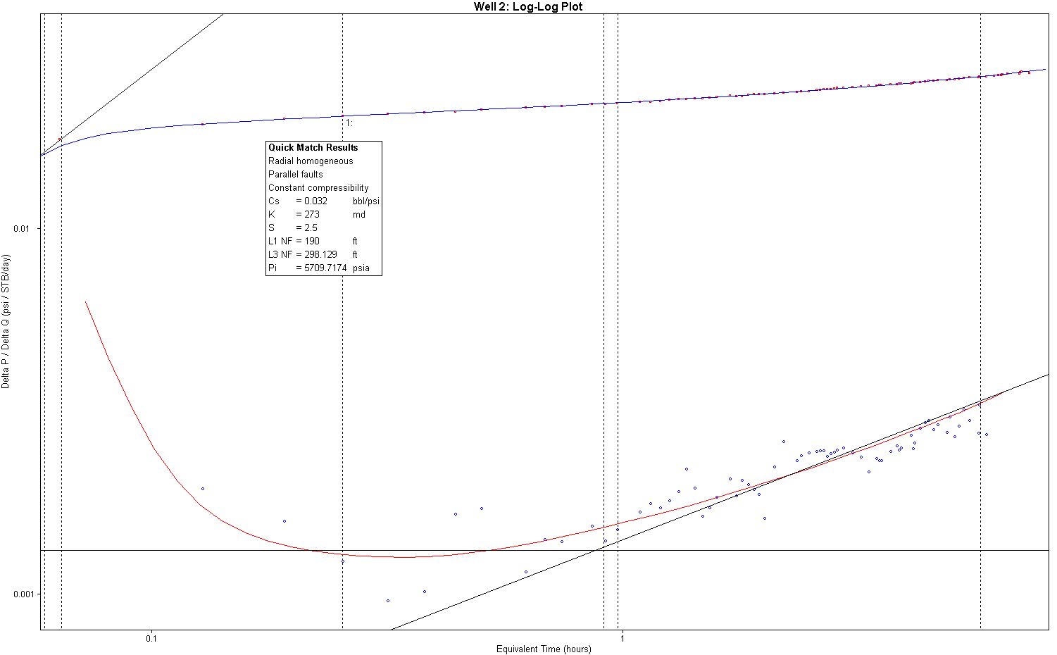

Figure F.7
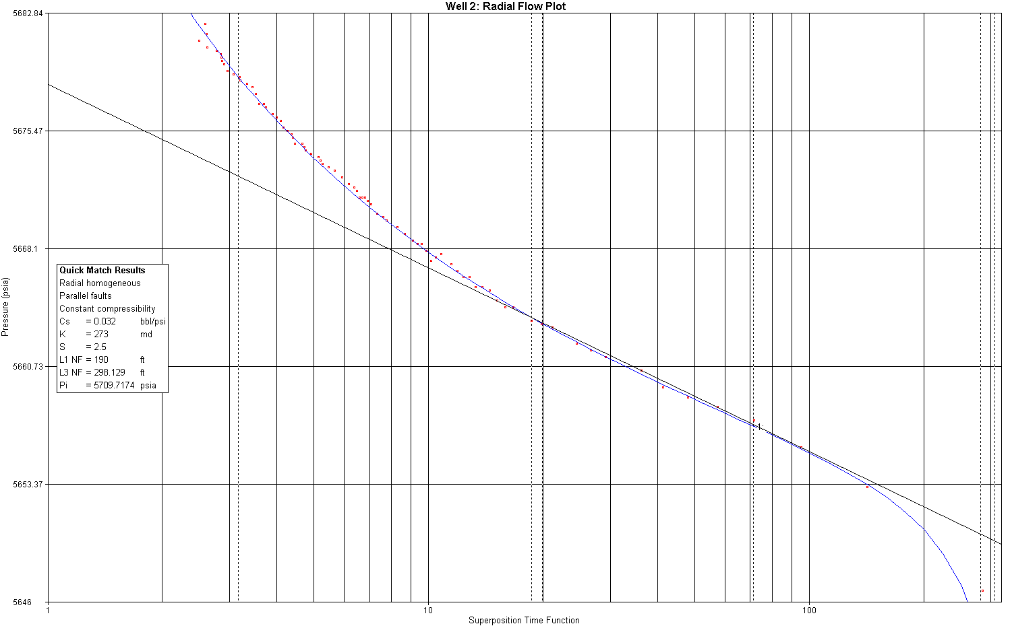

Figure F.8

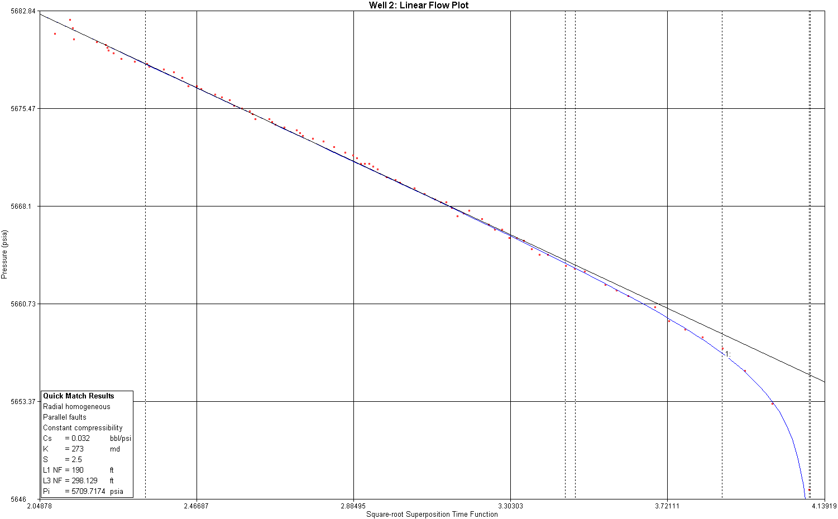

Figure F.9
Well 2( Injectivity Test)
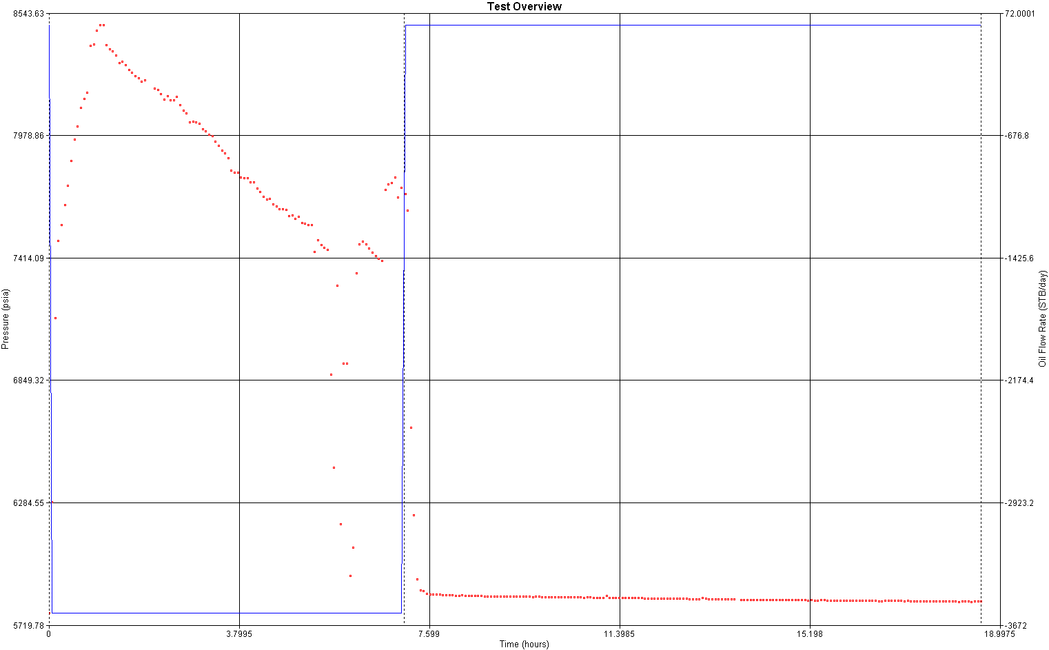

Figure F.10

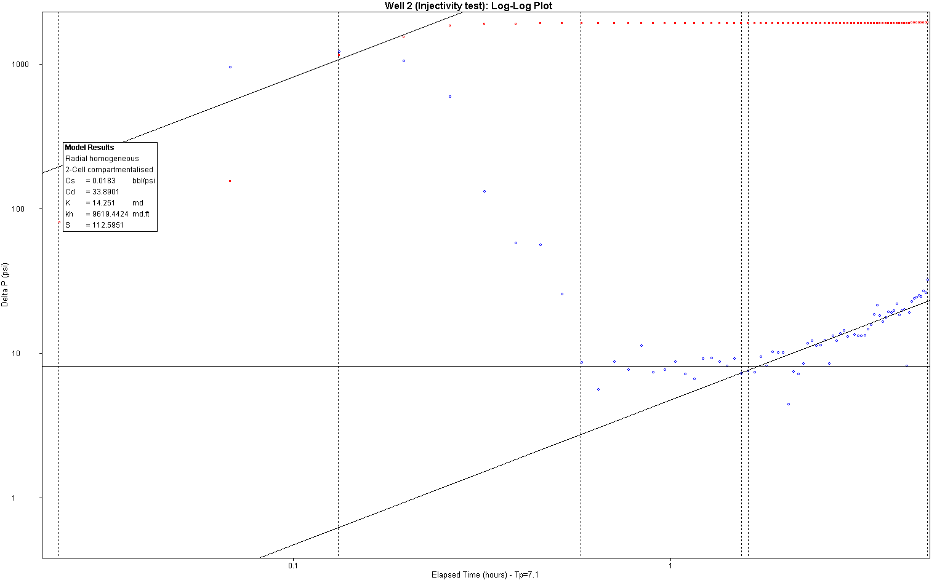

Figure F.11

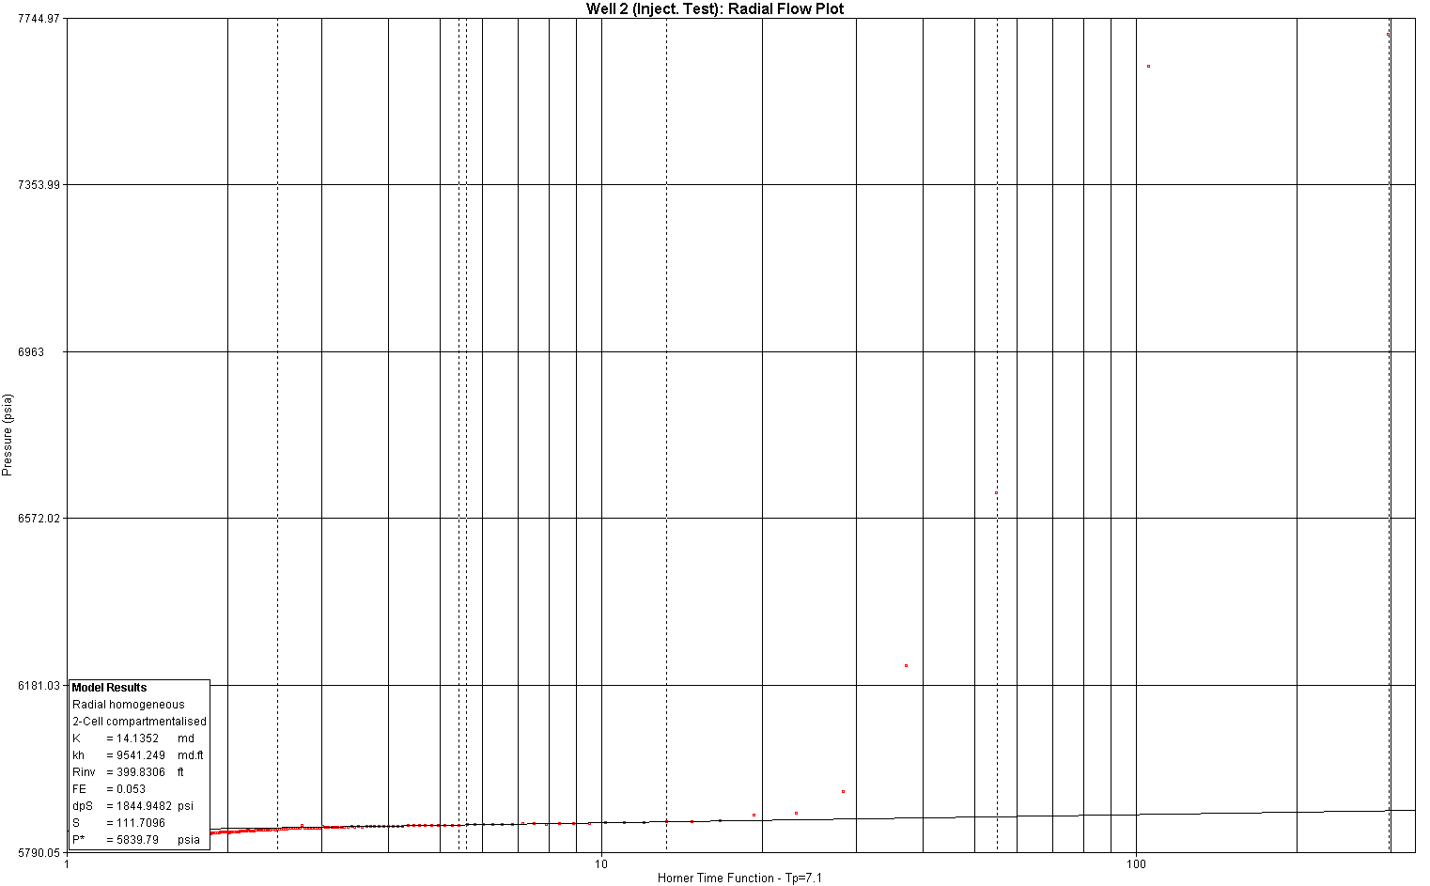

Figure F.12
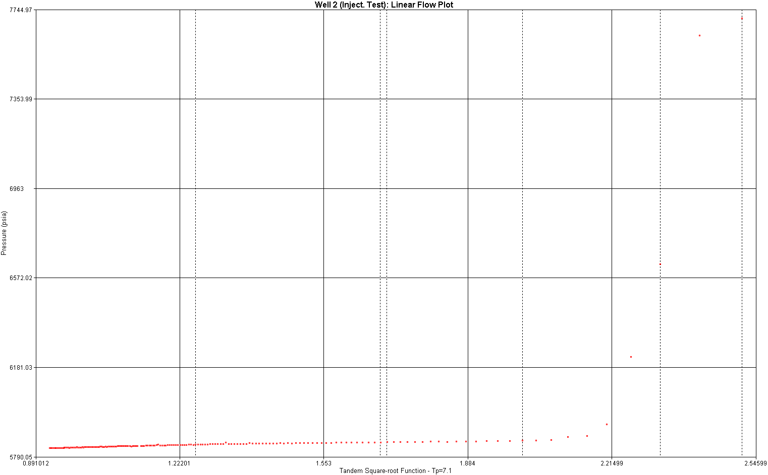

Figure F.13
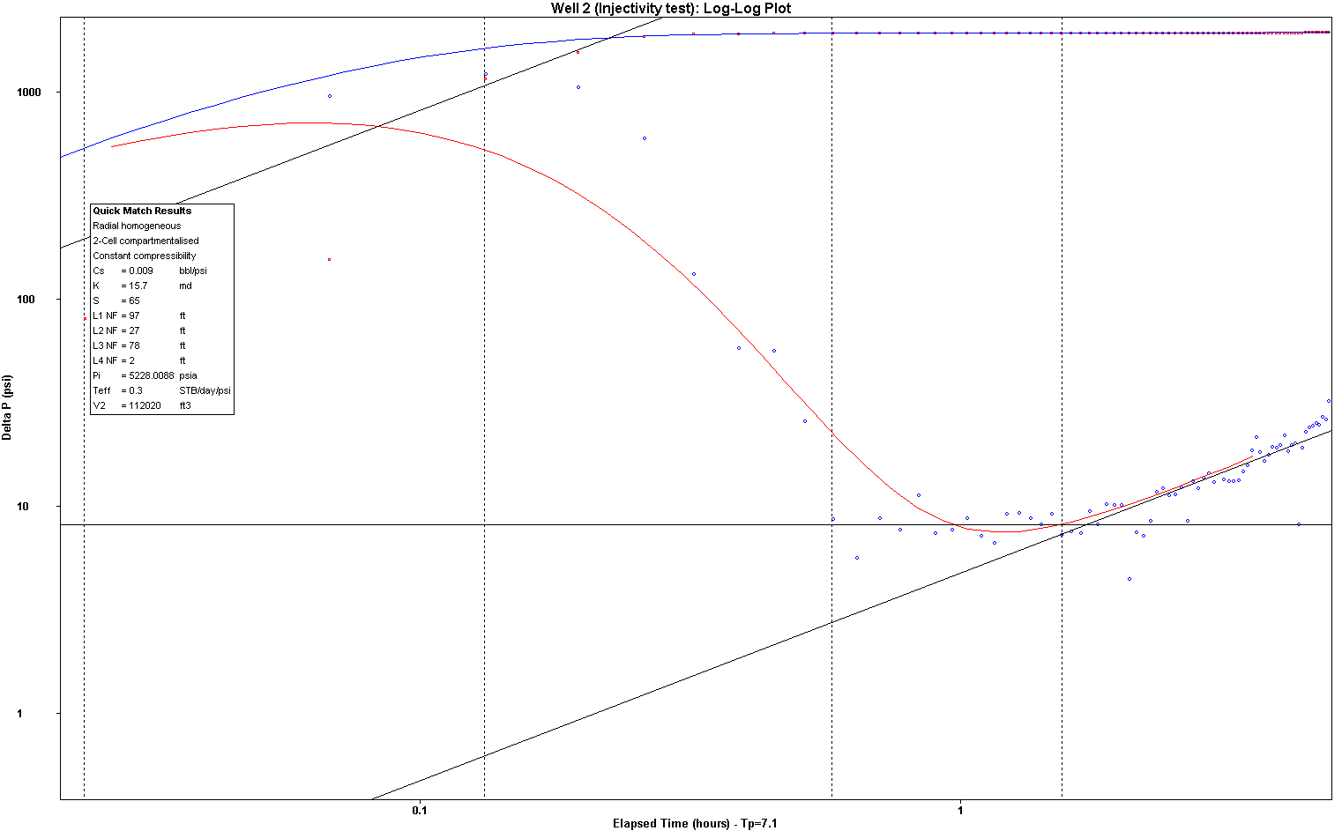

Figure F.14

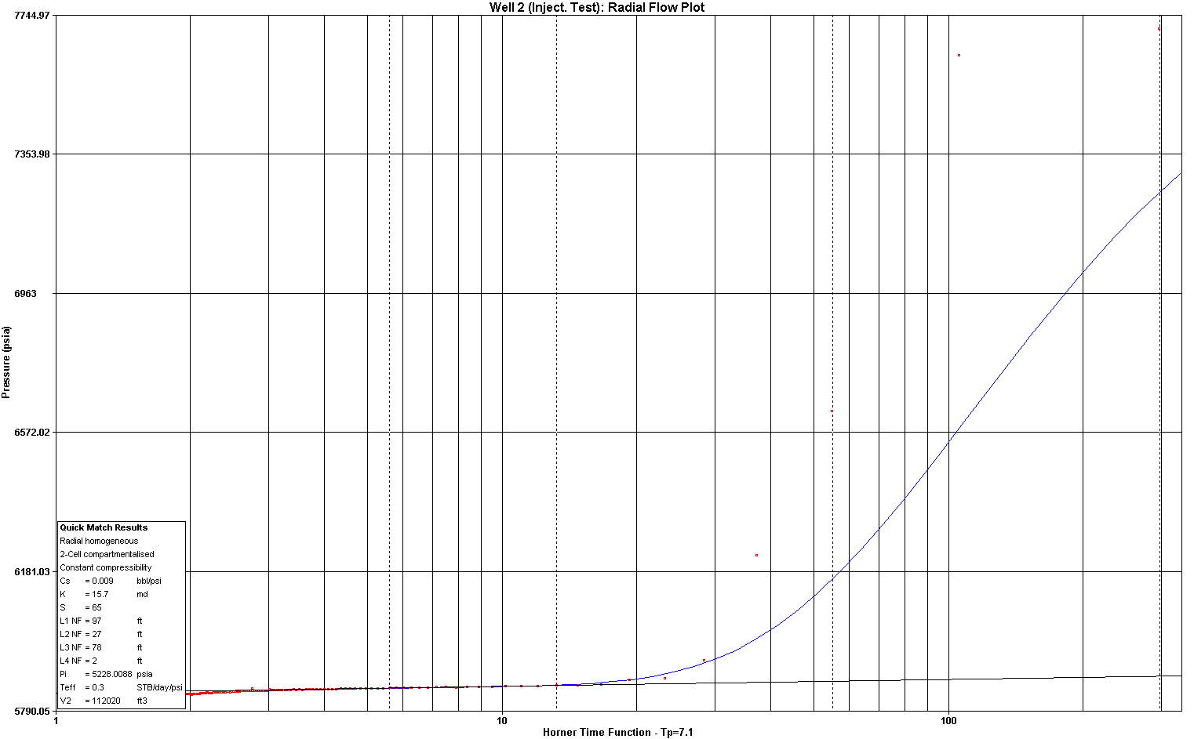

Figure F.15
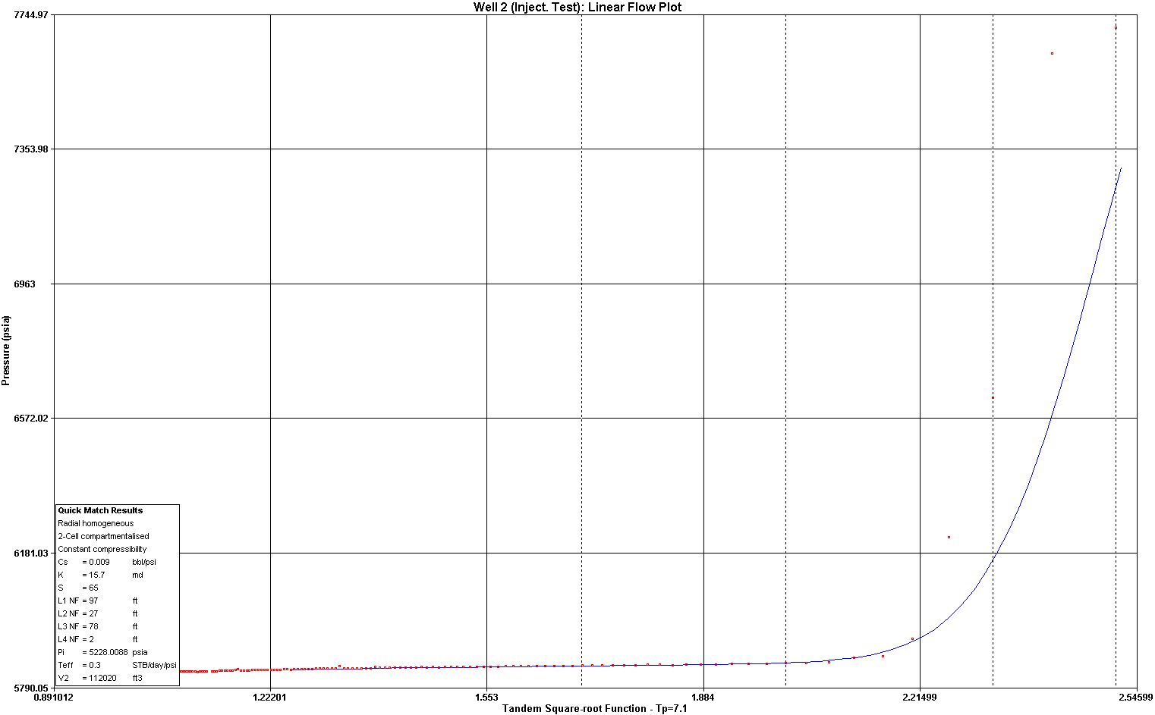

Figure F.16
Well 3:
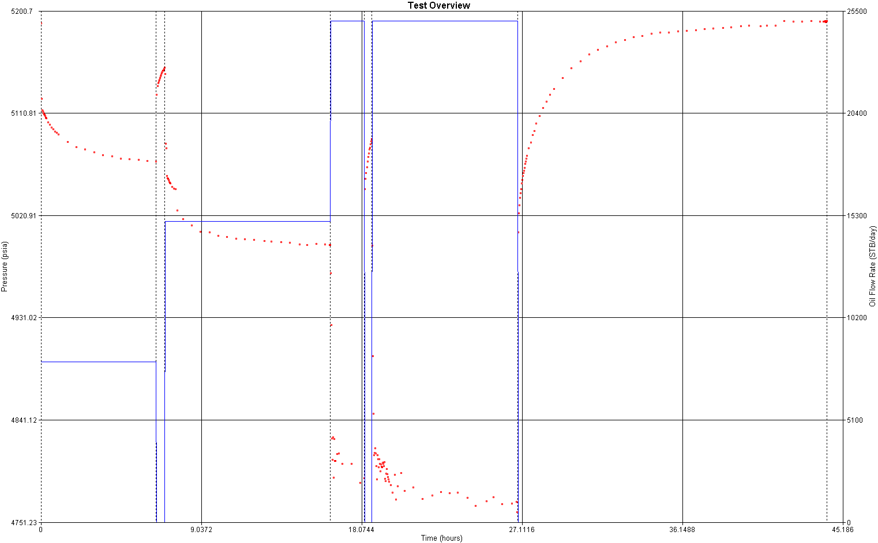

Figure F.17
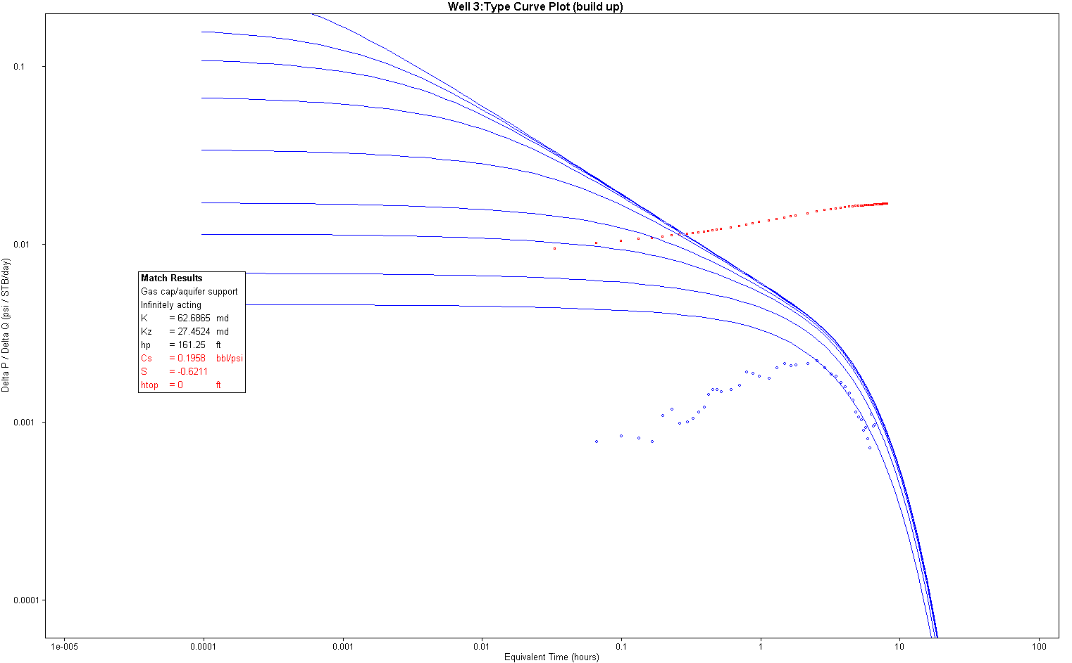

Figure F.18

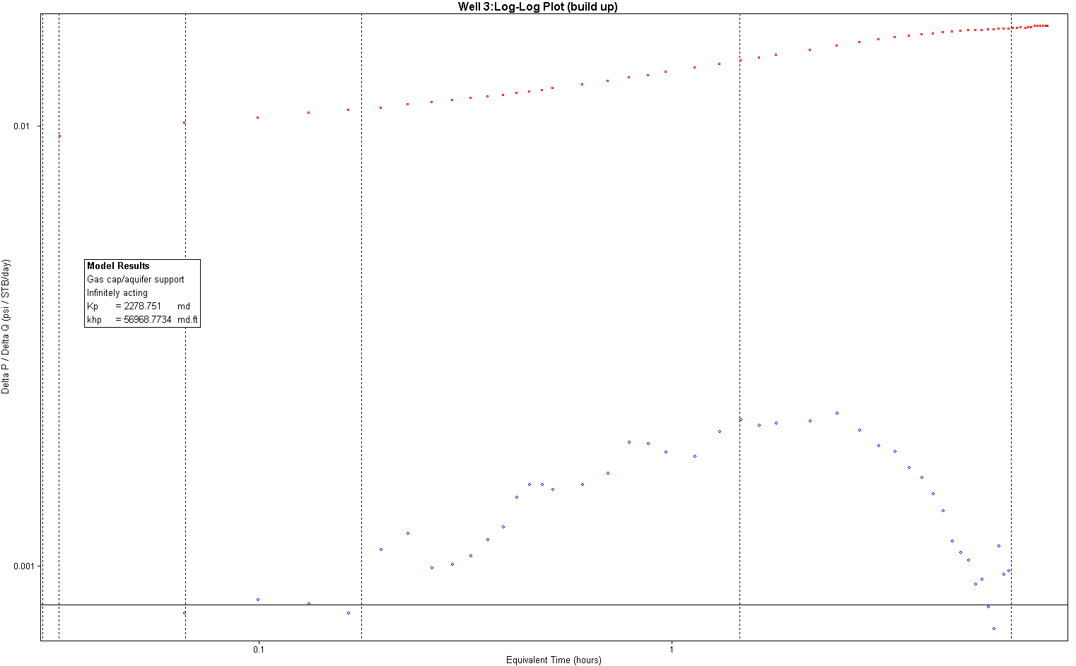

Figure F.19
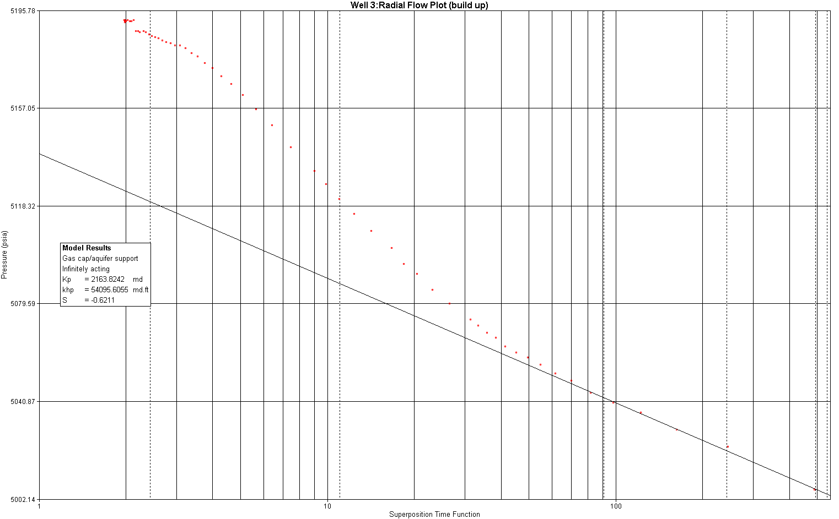

Figure F.20

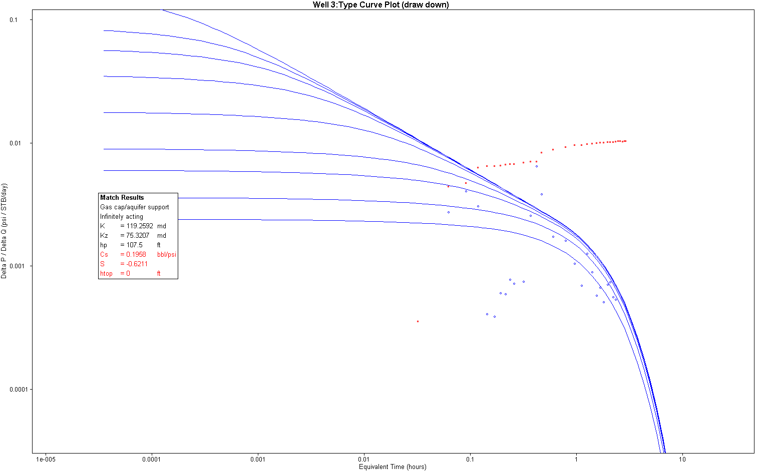

Figure F.21
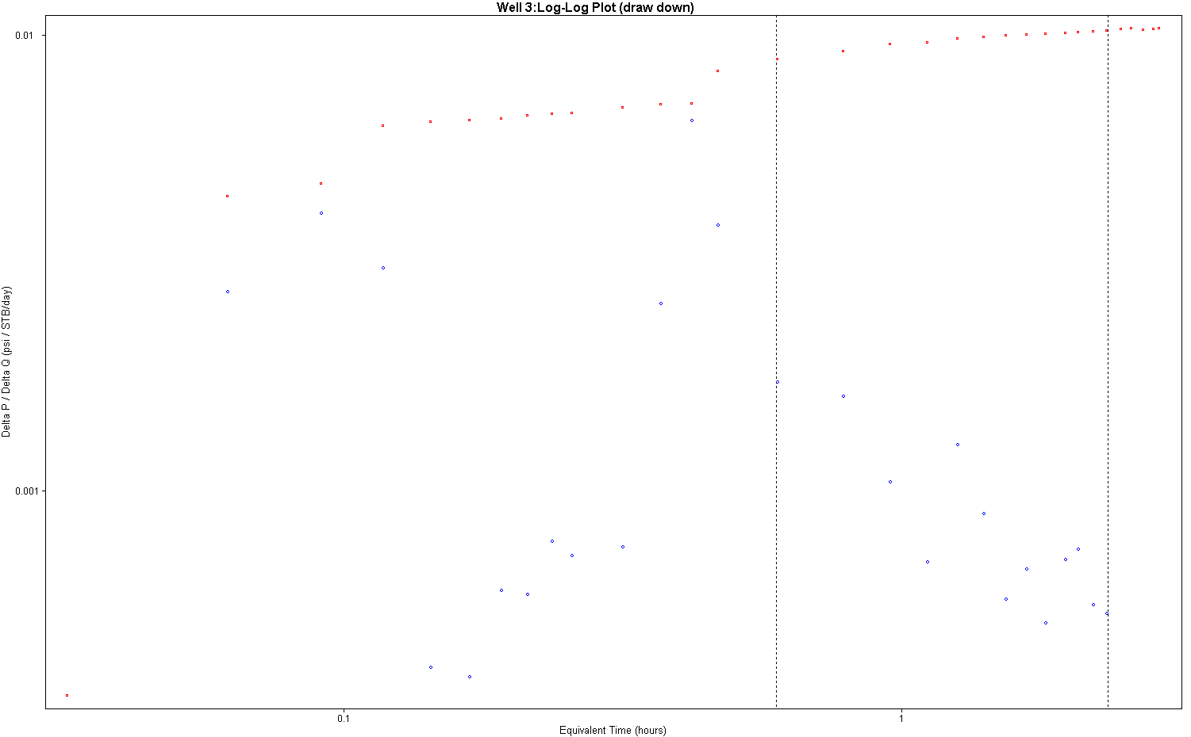

Figure F.22
Well 5:
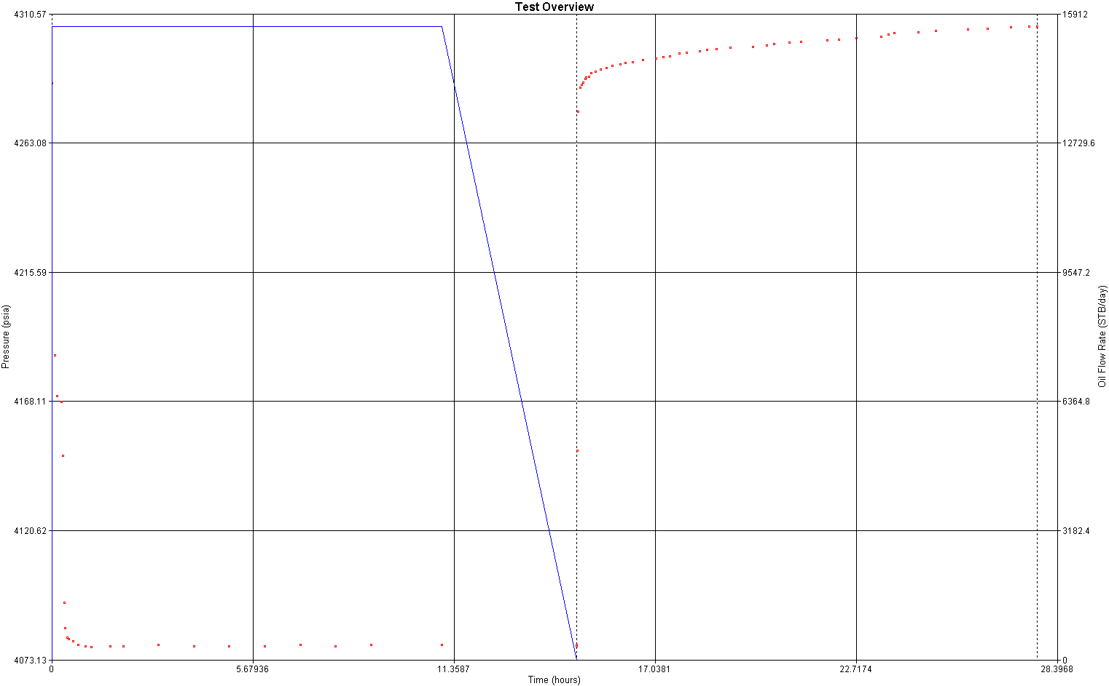

Figure F.23
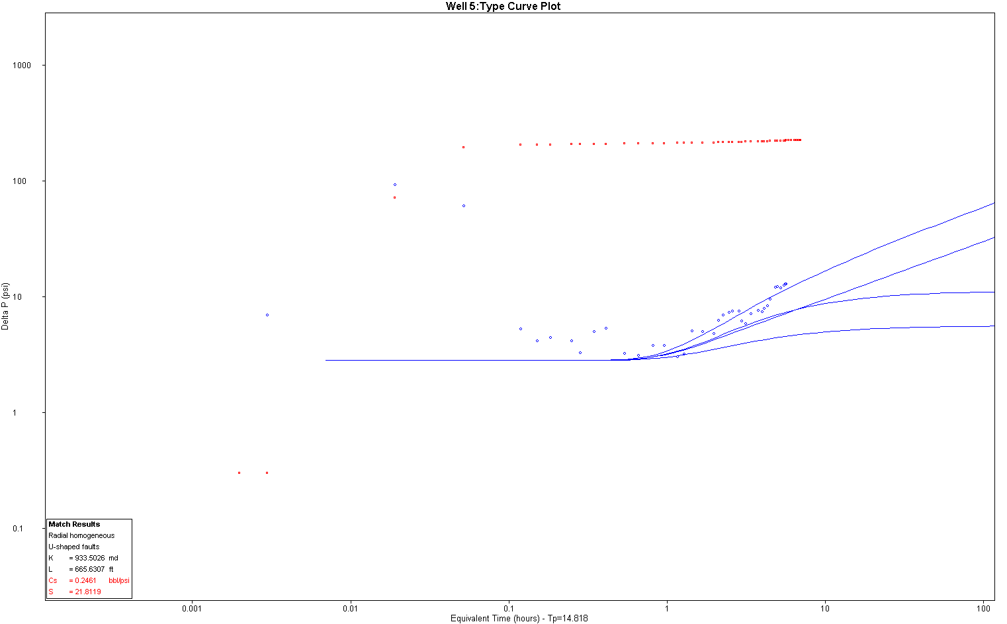

Figure F.24
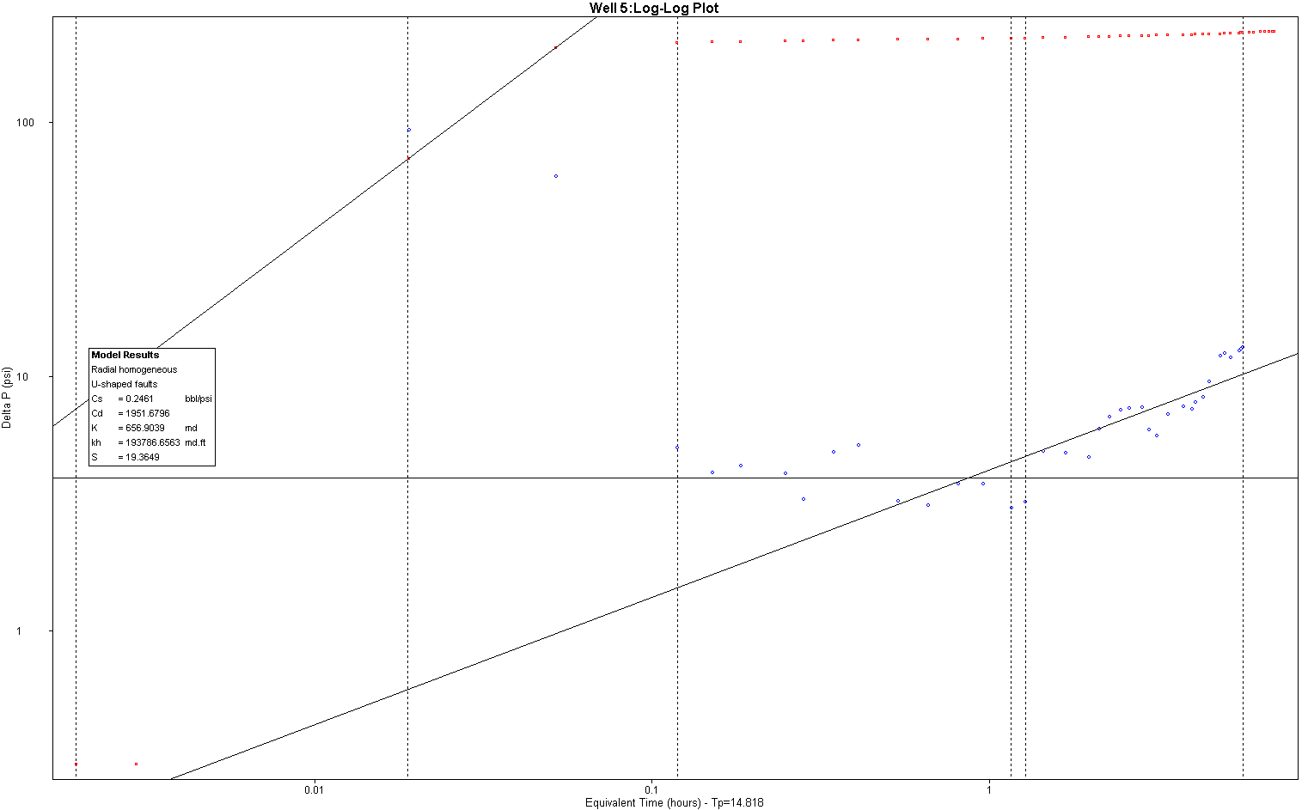

Figure F.25

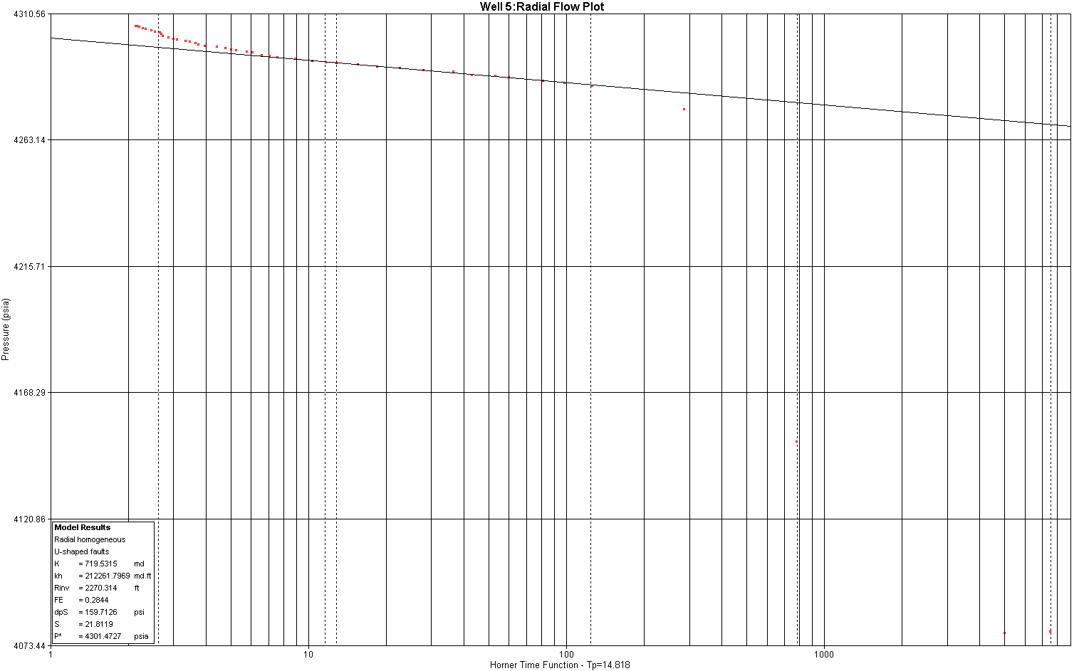

Figure F.26

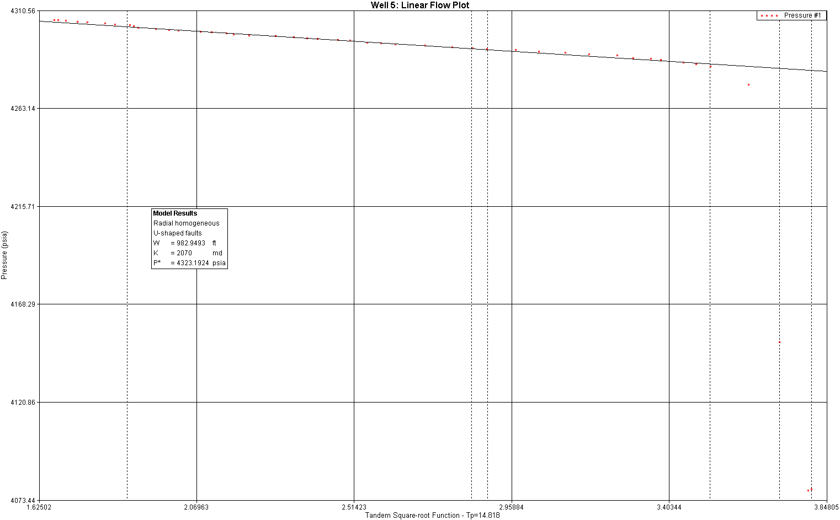

Figure F.27
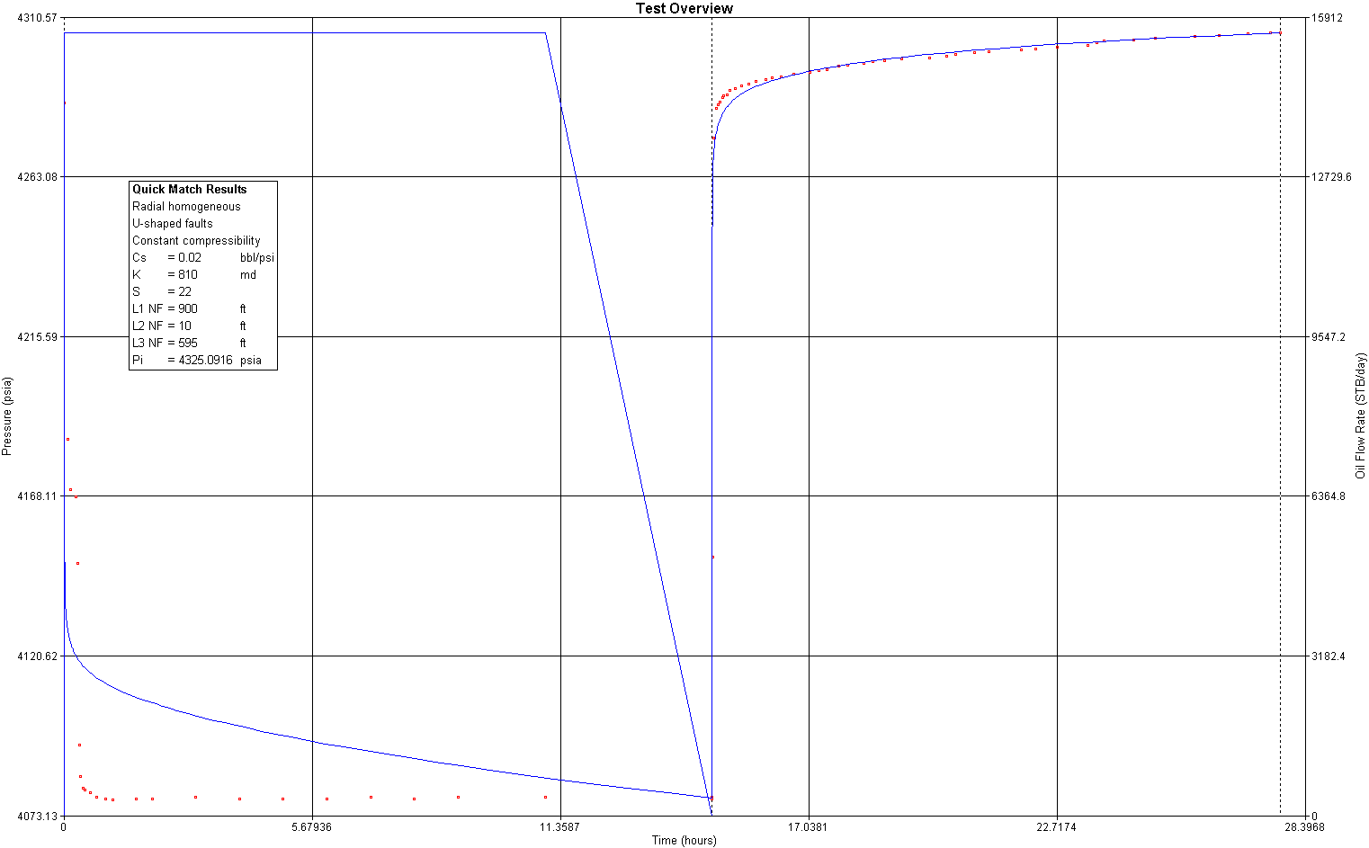

Figure F.28

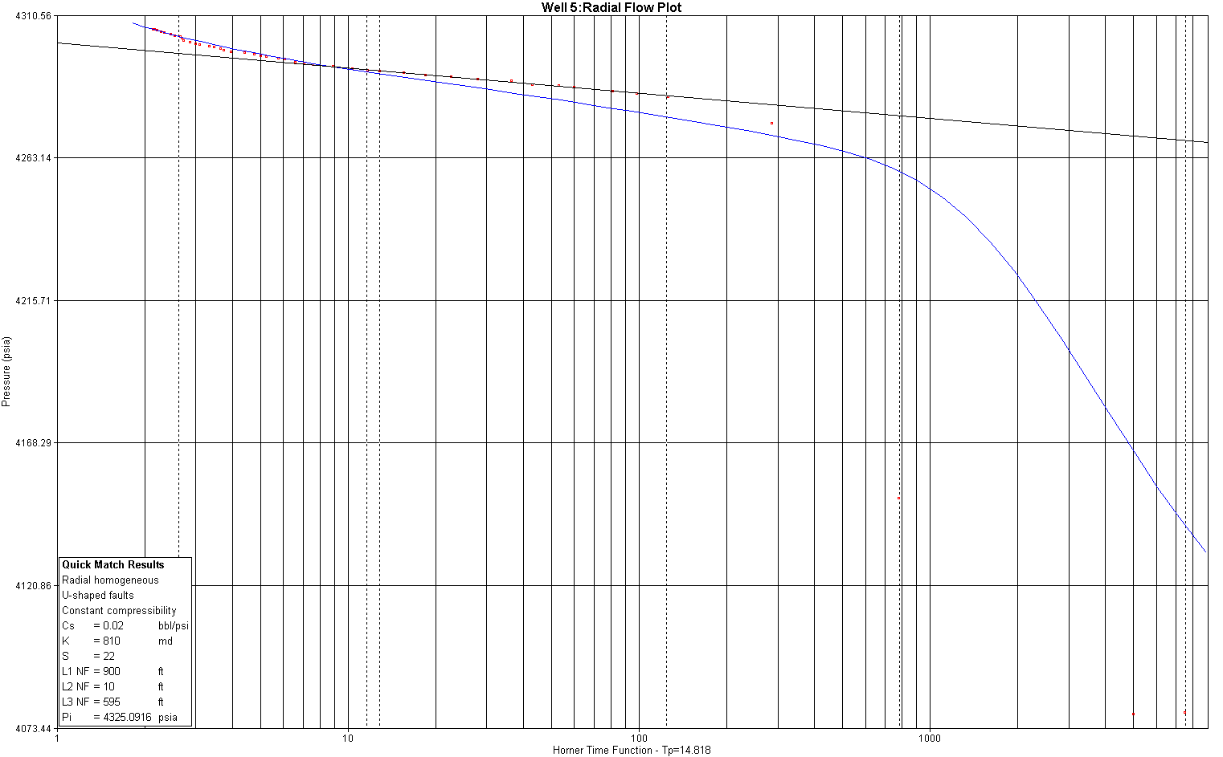

Figure F.29
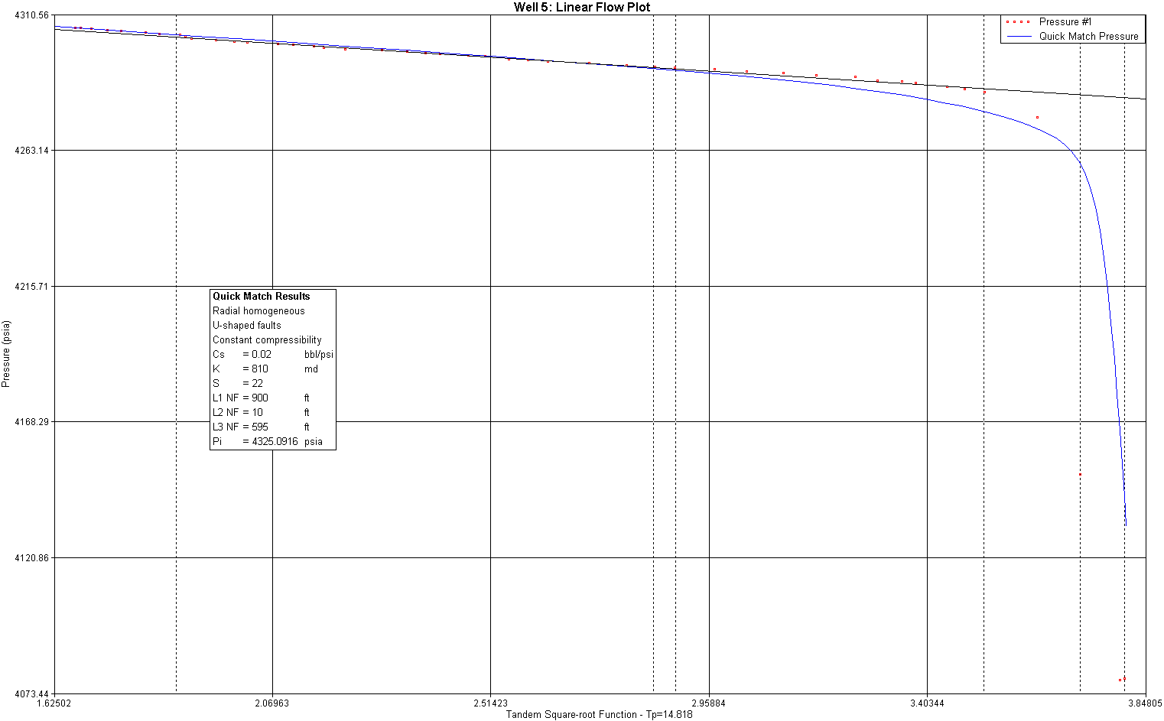

Figure F.30
Well 6:
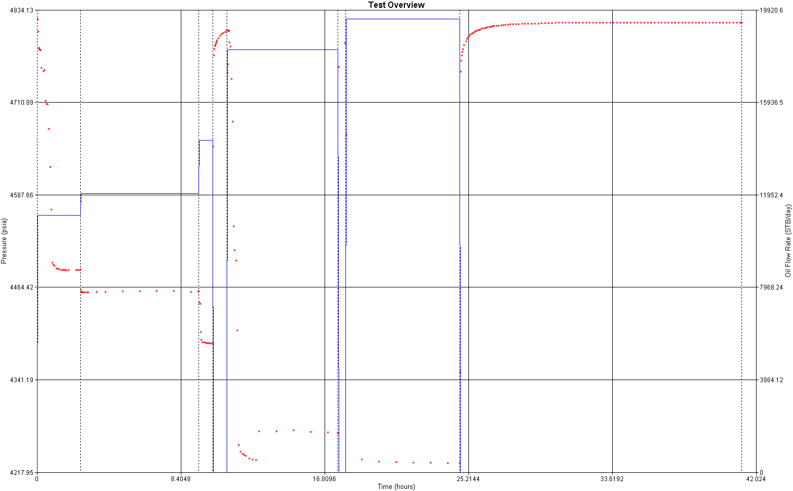

Figure F.31

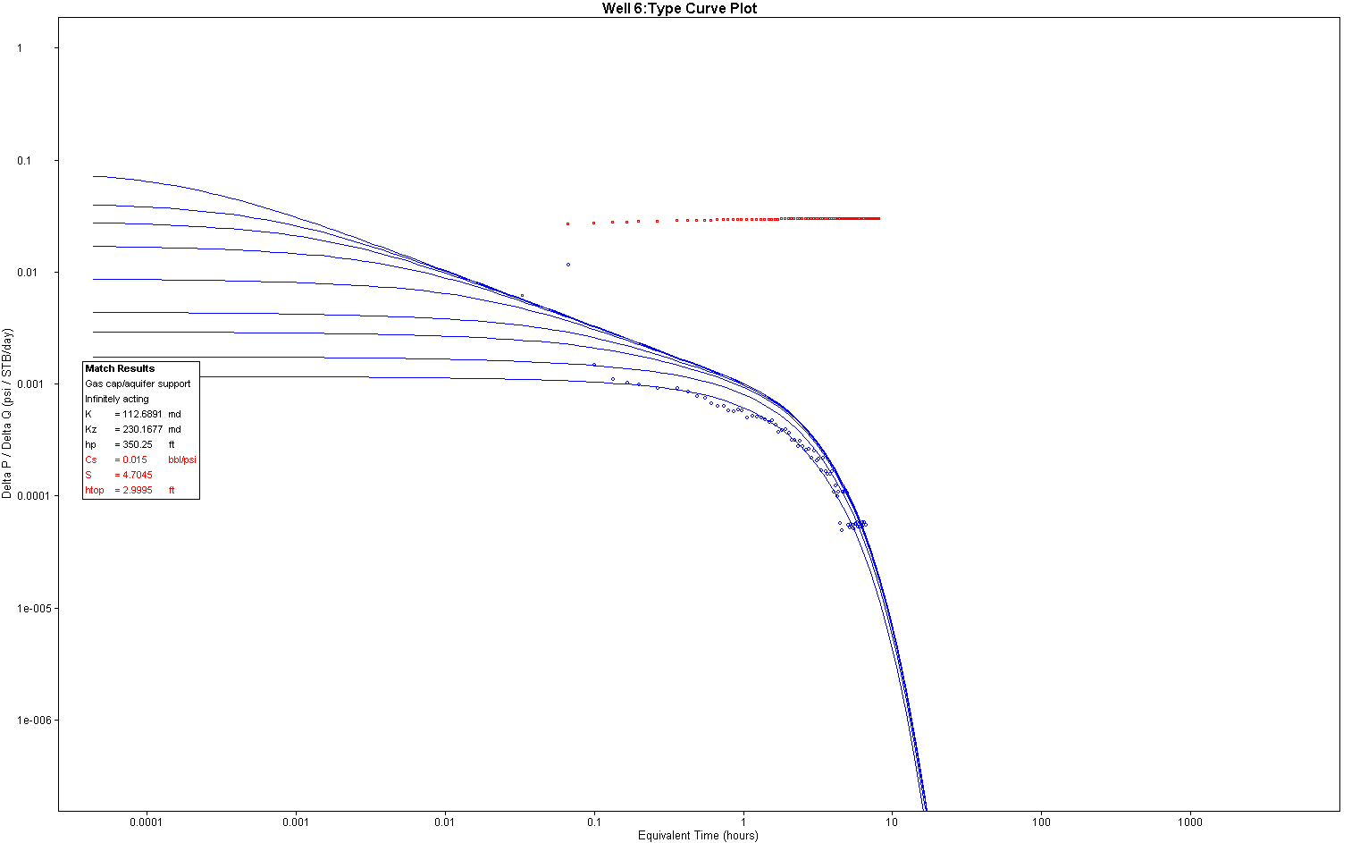

Figure F.32
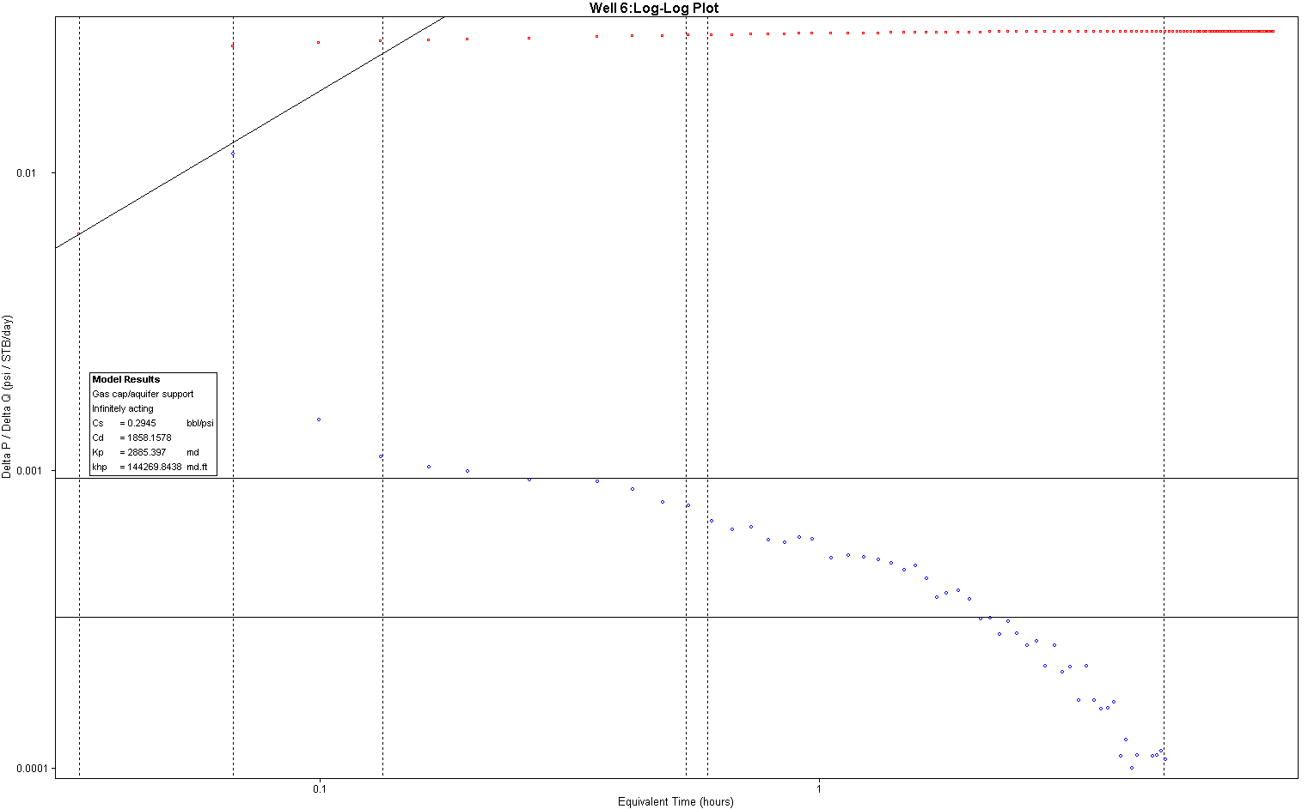

Figure F.33

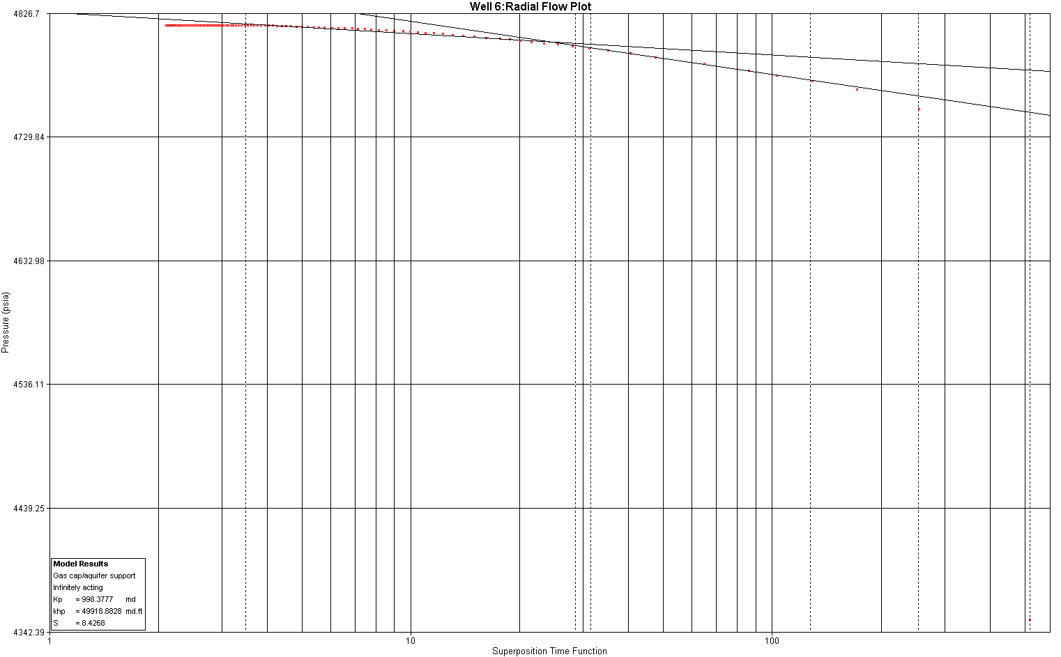

Figure F.34
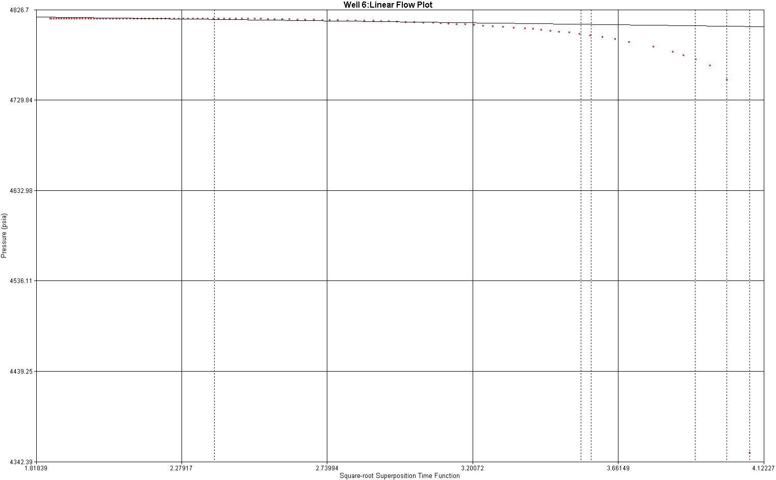

Figure F.35
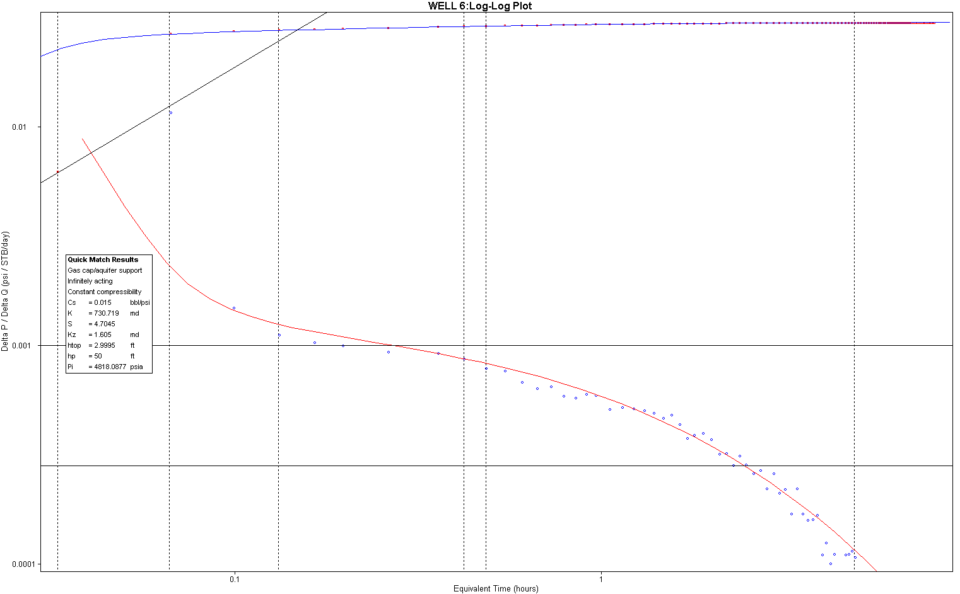

Figure F.36
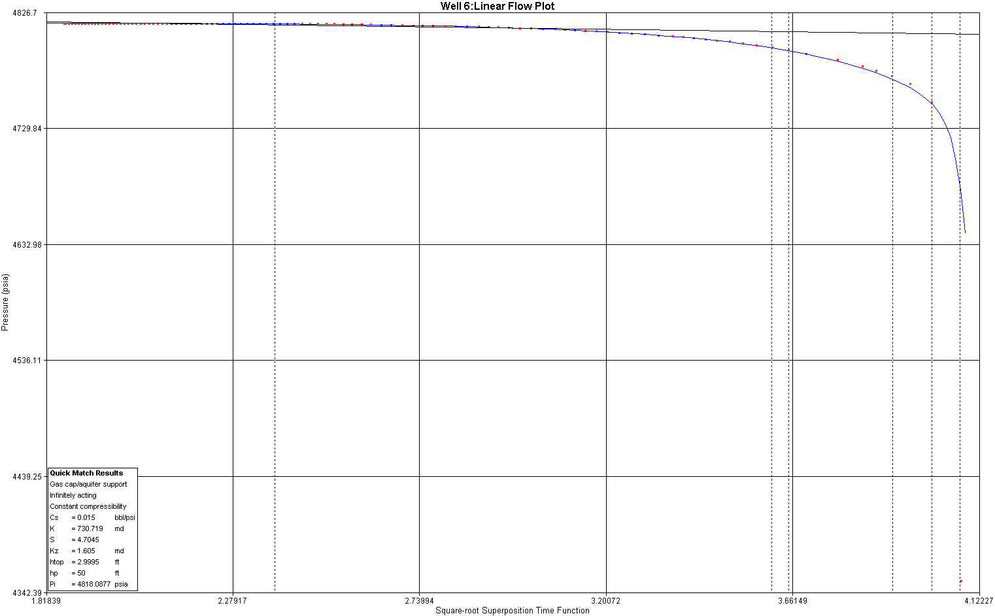

Table K.4: Drilling Costs.

Vertical wells | Number wells | Unit rate | Total cost |  | Water injection | Number wells | Unit rate | Total cost
Xmas tree | 1 | 852300 | 852300 |  | Xmas tree | 1 | 621600 | 621600
Wellhead | 1 | 165100 | 165100 |  | Wellhead | 1 | 78600 | 78600
Completion | 1 | 55000 | 55000 |  | Completion | 1 | 22000 | 22000
Downhole | 1 | 280600 | 280600 |  | Downhole | 1 | 280600 | 280600
Freight |  | 2.00% | 27060 |  | Freight |  | 2.00% | 20056
Subtotal |  |  | 1380060 |  | Subtotal |  |  | 742256
Drilling/Completion |  | Unit rate | Total cost |  | Drilling/Completion |  | Unit rate | Total cost
Casing/Tubing | Meters |  |  |  | Casing/Tubing | Meters
30" casing | 130 | 870 | 113100 |  | 30" casing | 150 | 357 | 53550
20"casing | 450 | 100 | 45000 |  | 20"casing | 450 | 100 | 45000
13 3/8" casing | 1816 | 50 | 90800 |  | 13 3/8" casing | 1743 | 50 | 87150
9 5/8" casing | 3384 | 43 | 145512 |  | 9 5/8" casing | 2790 | 43 | 119970
7" liner | 450 | 23 | 10350 |  | 7" liner | 756 | 23 | 17388
4.5" tubing | 3215 | 42 | 135030 |  | 5" tubing | 0 | 42 | 0
3 1/2" tubing | 0 | 28 | 0 |  | 3 1/2" tubing | 3486 | 28 | 97608
Cement | 3250 | 15 | 48750 |  | Cement | 3486 | 15 | 52290
Mud | 3250 | 67 | 217750 |  | Mud | 3486 | 67 | 233562
Bits | 3250 | 45 | 146250 |  | Bits | 3486 | 45 | 156870
Conductor | 0 | 870 | 0 |  | Conductor |  | 870 | 0
Drilling Template | 0.071428571 | 8500 | 607.1428571 |  | Drilling Template |  | 8500 | 0
Freight | 1.50% |  | 14297.23714 |  | Freight | 1.50% |  | 12950.82
Subtotal |  |  | 967446.38 |  | Subtotal |  |  | 876338.82
 | Days |  |  |  |  | Days
From Jackup | 40 | 45333 | 1813320 |  | From Jackup | 40 | 23900 | 956000
Bare rig charter | 40 | 36000 | 1440000 |  | Bare rig charter | 40 |  | 0
Drill crew | 40 | 7800 | 312000 |  | Drill crew | 40 | 6200 | 248000
Drill marine | 40 | 3600 | 144000 |  | Consumables | 40 | 6700 | 268000
Consumables | 40 | 6700 | 268000 |  | Helicopter services | 40 | 2000 | 80000
Helicopter services | 40 | 2000 | 80000 |  | Supply boats | 40 | 6300 | 252000
Supply boats | 40 | 6300 | 252000 |  | Supply base | 40 | 2700 | 108000
Supply base | 40 | 2700 | 108000
Specialist services | Number | Unit rate |  |  | Specialist services | Number | Unit rate
Logging | 1 | 330000 | 330000
Cementing | 1 | 80000 | 80000 |  | Cementing | 1 | 80000 | 80000
Testing | 1 | 130000 | 130000
Subtotal |  |  | 2353320 |  | Subtotal |  |  | 1992000
Design | 500 | 43 | 21500 |  | Design | 500 | 43 | 21500
Project management | 334 | 85 | 28390 |  | Project management | 334 | 85 | 28390
Certification | 1.50% |  | 748.35 |  | Certification | 1.50% |  | 748.35
Contingency | 20.00% |  | 940165.276 |  | Contingency | 20.00% |  | 722118.96
Total (£mm 2001) |  |  | 4724183.626 |  | Total |  |  | 3507013.3
Total ($mm 2001) |  |  | 7086275.439 |  | Total ($mm 2001) |  |  | 5260520

 |  | Alias: |  | Drilling 1
 |  |  |  | UNIT RATE |  | TOTAL COSTS
PRODUCTION WELLS |  |  | 14 |  | No.
 | 14 | No. |  | 2,060,700 |  | 28,850,000
 | 14 | No. |  | 677,300 |  | 9,482,000
 | 14 | No. |  | 57,500 |  | 805,000
Downhole ESP |  |  |  |  | No. | 404,800
GAS INJ. WELLS |  |  |  |  | No.
 |  | No. |  | 310,000
 |  | No. |  | 62,000
 |  | No. |  | 23,000
WATER INJ. WELLS |  |  | 6 |  | No.
 | 6 | No. |  | 1,573,500 |  | 9,441,000
 | 6 | No. |  | 308,800 |  | 1,853,000
 | 6 | No. |  | 23,000 |  | 138,000
 |  |  |  |  |  | 50,569,000
 | 2 | % of SUBTOTAL |  |  |  | 1,011,000
EQUIPMENT |  |  |  |  |  |  | 51,580,000
DRILLING/COMPLETION
Casing / Tubing |  |  |  |  | m
casing | 3,000 | m |  | 380 |  | 1,140,000
casing | 9,000 | m |  | 110 |  | 990,000
casing | 34,300 | m |  | 80 |  | 2,744,000
casing | 54,900 | m |  | 45 |  | 2,471,000
liner | 14,900 | m |  | 25 |  | 373,000
tubing | 68,600 | m |  | 48 |  | 3,293,000
tubing |  | m |  | 30
 | 68,640 | m |  | 16 |  | 1,098,000
 | 68,640 | m |  | 70 |  | 4,805,000
 | 68,640 | m |  | 48 |  | 3,295,000
 | 68,640 | m |  | 55 |  | 3,775,000
CONDUCTORS |  |  |  |  | t | 900
DRILLING TEMPLATE |  |  |  |  | t | 8,500
 |  |  |  |  |  | 23,984,000
 | 1.5 | % of SUBTOTAL |  |  |  | 360,000
MATERIALS |  |  |  |  |  |  | 24,344,000
FROM FLOATING |  |  | 1,427 |  | Days | 110,300 | 157,445,000
Bare rig charter |  |  | 1,427 |  | Days | 75,000 | 107,057,000
 | 1,427 | Days |  | 8,800 |  | 12,561,000
Marine crew |  |  | 1,427 |  | Days | 5,200 | 7,423,000
Consumables |  |  | 1,427 |  | Days | 8,000 | 11,419,000
Helicopter services |  |  | 1,427 |  | Days | 2,100 | 2,998,000
Supply boats |  |  | 1,427 |  | Days | 8,500 | 12,133,000
Supply base |  |  | 1,427 |  | Days | 2,700 | 3,854,000
FROM JACK UP |  |  |  |  | Days
Bare rig charter |  |  |  |  | Days | 60,000
 |  | Days |  | 7,800
Marine crew |  |  |  |  | Days | 3,600
Consumables |  |  |  |  | Days | 7,000
Helicopter services |  |  |  |  | Days | 2,100
Supply boats |  |  |  |  | Days | 5,000
Supply base |  |  |  |  | Days | 2,700
FROM PLATFORM |  |  |  |  | Days
 |  | Days
 |  | Days |  | 6,200
 |  | Days
 |  | Days |  | 7,000
 |  | Days |  | 2,100
 |  | Days |  | 5,000
 |  | Days |  | 2,700
FROM PLATFORM + TSV |  |  |  |  | Days
 |  | Days |  | 36,000
 |  | Days |  | 6,200
 |  | Days |  | 5,200
 |  | Days |  | 8,000
 |  | Days |  | 2,100
 |  | Days |  | 8,500
 |  | Days |  | 2,700
FROM TLP / SPAR |  |  |  |  | Days
 |  | Days
 |  | Days |  | 6,200
 |  | Days |  | 3,600
 |  | Days |  | 7,000
 |  | Days |  | 2,100
 |  | Days |  | 5,000
 |  | Days |  | 2,700
SPECIALIST SERVICES
 | 14 | No. |  | 350,000 |  | 4,900,000
 | 20 | No. |  | 85,000 |  | 1,700,000
 | 14 | No. |  | 140,000 |  | 1,960,000
TRANSPORT |  |  | 7 |  | Days | 102,200 | 715,000
SITE PREPARATION |  |  |  |  | Days | 100,000
INSTALLATION |  |  |  |  |  |  | 166,720,000
 | 15,000 | Mhrs |  | 85 |  | 1,275,000
PROJECT MGMT |  |  | 10,000 |  | Mhrs | 90 | 900,000
CERTIFICATION |  |  | 5% |  |  |  | 12,241,000
CONTINGENCY |  |  | 20% |  |  |  | 51,412,000
TOTAL COST : |  |  |  |  |  | UK POUNDS | 308,472,000

 |  |  |  | Alias | Floater 1
 |  | WEIGHT t |  | UNIT RATE | TOTAL COSTS
VESSEL PURCHASE |  |  |  | d |  | 41,500,000
SWIVELS/DISCONNECT
 |  | 2 off |  | 1,000,000 | 2,000,000
 |  | 6 off |  | 2,100,000 | 12,600,000
 |  |  |  | 265,000
12 x | 4.5 in | 9,072 m |  | 446 | 4,041,000
 |  | 9,072 m |  | 195 | 1,769,000
 |  | 12 |  | 71,000 | 852,000
WIRE TERMINATIONS |  |  |  | 24 off | 14,000 | 336,000
 |  |  |  |  | 63,098,000
 |  | 1,800 |  | 500 | 900,000
MARINE/OFFLOADING |  |  |  | 200 | 14,200 | 2,840,000
GENERAL UPGRADE |  |  |  | 100 | 6,800 | 680,000
TURRET/ FRAME ETC
Frame / Mooring Arm |  |  |  | 400 | 950 | 380,000
 |  | 1000 |  | 1,300 | 1,300,000
Chaintable / Buoy
 |  | 876 |  | 750 | 657,000
 |  | 6 |  | % OF SUB | 405,420
 |  |  |  |  | 7,162,000
VESSEL ST'GTHENING |  |  |  | 1,800 | 2,200 | 3,960,000
MARINE/OFFLOADING |  |  |  | 200 | 4,700 | 940,000
GENERAL UPGRADE |  |  |  | 100 | 4,200 | 420,000
 |  | 1,400 |  | 3,700 | 5,180,000
 |  | 876 |  | 1,500 | 1,314,000
 |  |  |  |  | 11,814,000
 |  | 20 Days |  | 105,000 | 2,100,000
INSTALLATION |  |  |  |  |  | 2,100,000
SEA TR'L & M'NE COMM' |  |  |  | 15 Days | 100,000 | 1,500,000
 |  |  |  |  | 1,500,000
 |  | 65,000 Mhrs |  | 50 | 3,250,000
 |  | 42,500 Mhrs |  | 90 | 3,825,000
 |  | 8% |  |  | 7,420,000
 |  | 20% |  |  | 20,034,000
 |  |  |  | UK POUNDS | 120,203,000

 |  | Alias: | Subsea 1
 |  | WELLS | TYPE |  | TOTAL COSTS
1 |  | 10 | Template |  | 13,799,000
2 |  | 4 | Cluster |  | 5,137,000
3 |  | 10 | Template |  | 12,980,000
4 |  |  | Platform
5 |  |  | Manifold |  | 158,000
16
 |  | 22 | 245,000 |  | 5,390,000
 |  |  |  |  | 37,464,000
 |  | 2 % | of subtotal |  | 749,000
 |  |  |  |  | 38,213,000
 |  | QTY | UNIT RATE |  | TOTAL COSTS
 | 2"
 | 4"
 | 6"
 | 8"
 | 10"
 | 12"
 | 16"
RISER SYSTEMS ( Arch/Buoy )
 |  | 1.3 km | 130,000 |  | 165,000
 |  |  |  |  | 165,000
 |  | 1.5 % | of subtotal |  | 2,000
 |  |  |  |  | 167,000
 |  |  | 80,000
 |  | 34 Days | 105,000 |  | 3,570,000
 |  | 32 Days | 150,000 |  | 4,800,000
 | (SDP) |  | 230,000
TRENCHING / BURIAL SPREAD |  |  |  |  |  | 70,000
 |  |  |  |  | 8,370,000
 |  | 60,400 Hrs | 50 |  | 3,020,000
PROJECT MANAGEMENT |  |  |  |  | 16,000 Hrs | 90 |  | 1,440,000
 |  | 5% |  |  | 2,561,000
 |  | 20% |  |  | 10,754,000
 |  | UK POUNDS |  |  | 64,525,000

